Journal of Gazi University Health Sciences Institute
journal homepage: https://dergipark.org.tr/tr/pub/guhes

Title of The Manuscript (Times New Roman 12 pt, Max 20 Words, each word should begin with a capital letter (except for 'of', 'in', 'and', etc.)

Author (Name Surname)¹, Author² (Times New Roman 12 pt)

¹ Affilation (Times New Roman 9 pt)
² Affiliation (Times New Roman 9 pt)

Abstract
Times New Roman 10 pt (Maximum 250 words)
Abstract should be written in paragraph form without being divided into headings.

Only English summaries should be written.

Keywords: keyword1, keyword2, keyword3, keyword4, keyword5 (According to MeSH index) (Alphabetical order, If it's a proper noun, capitalize the first letter; if not, use lowercase for the first letter.)

Author name (Corresponding author); ORCID: …….. e-mail adress (Times New Roman 10 pt), Author name; e-mail adress, ORCID: …….. (Times New Roman 10 pt)

- Introduction
Times New Roman 11 pt
- Materials and Methods
Times New Roman 11 pt (The information in the Material Method section of the journal writing rules should be included).
2.1. Subtitle (if necessary)
Times New Roman 11 pt
- Results
Times New Roman 11 pt
- Discussion
Times New Roman 11 pt
- Conclusion
Times New Roman 11 pt
Ethical Statement
Ethical approval for this study was obtained from [Name of the Ethics Committee/Board] on [Date], with approval number [Number], as stated in the methods section.

If ethical approval is not required;
There is no need to obtain ethics committee permission for this study due to …… reasons. However, the study was conducted in accordance with ethical principles.

For Case Report;
Since this is a case report, ethical approval was not obtained. However, signed informed consent was obtained from the patient.

Financial Support for the Study
This research was conducted with financial support from [Research Institution/Company Name]. The financial support was utilized in the processes of data collection, analysis, and publication.
if there is no financial support;
This study did not receive any financial support.
Presentation Information
The data from this study were presented at [Conference Name/Location] conference/[Journal Name] journal. The presentation date was [Date].
If no presentation was made for the study;
The findings of this study have not been presented at any conference or journal.
Conflicts of Interest
The authors declare no conflicts of interest regarding this study. Any institution or organization providing funding for this research did not have any role in the design, data collection, analysis, interpretation, or publication to influence or distort the findings.
Author Contributions
The contributions of the authors are as follows: [Author 1] participated in data collection and analysis; [Author 2] prepared the draft of the paper; [Author 3] conducted the final revision of the manuscript.
If the article has a single author
The entirety of the all process of the article belongs to the author.
Acknowledgment (optional)
We would like to thank [Company/Institution/Name] for their support in conducting this study. Additionally, we extend our gratitude to [Name] for their contributions.
References
Times New Roman 10 pt
DOI number should be given with https extension
Al-Ramadhani, G.O., & Al-Mtioti S. (2019). Determination of mesalazine spectrophotometry based on the charge transfer complex n- π using reagent p-bromanil. Journal of Education And Science, 28 (2), 71-84. http://dx.doi.org/10.33899/edusj.2019.161178
Altayib, F., Abdalla, A., & Elbashir, A.A., (2014). Development and validation of spectrophot-ometric methods for the determination of mesalazine in pharmaceutical formulation. Medicinal Chemistry, 4 (3), 361-366. http://dx.doi.org/10.4172/2161-0444.1000166

Figures and tables should be added to single-column pages at the end of the article, with a table/figure on each page (as below).

Table 1. The most purchased foods with the effect of advertising
Food Group | Male |  | Female
 | n | % | n | %
Meat and meat products | 57 | 18.1 | 47 | 6.4
Milk, yoghurt etc. | 35 | 11.1 | 64 | 8.7
Fruit and vegetable | 8 | 2.5 | 20 | 2.7
Cereals, legumes | 3 | 1.0 | 12 | 1.6
Fats | 5 | 1.6 | 5 | 0.7
Fast food | 81 | 25.7 | 157 | 21.4
Chocolate, biscuit, cake | 105 | 33.3 | 407 | 55.4
Soft drink | 21 | 6.7 | 23 | 3.1
Total | 315 | 100 | 735 | 100

Table 2: Comparison of study and control groups in terms of biochemistry laboratory examination results; non-parametric data
 | Autism Group N=30  Mean Rank | Control Group N=30  Mean Rank | p-value
ALT (U/L) | 27.23 | 19.43 | 0.049*
TSH (µIU/mL) | 18.64 | 18.36 | 0.938
Ferritin (ng/ml) | 18.68 | 17.55 | 0.749

Table 3: Parameters for Power-Law equations at two different temperatures, 25 °C and 32 °C.
Power-law |  | Commercial product | 20%poloxamer  +5%PG | 20%poloxamer  +2,5%PG | 25%poloxamer  +5%PG
25 °C | K±SE | 19.147 ± 0.015 | 194.044 ± 0.021 | 676.993 ± 0.069 | 759.018 ± 0.019
 | n±SE | 2.378 ± 0.053 | 0.851 ± 0.020 | 0.401 ± 0.029 | 0.453 ± 0.009
 | R²±SE | 0.997 ± 0.014 | 0.860 ± 0.037 | 0.918 ± 0.048 | 0.990 ± 0.016
32 °C | K±SE | 10.285 ± 0.049 | 1734.156 ± 0.072 | 975.752 ± 0.109 | 5271.550 ± 0.111
 | n±SE | 2.086 ± 0.137 | 0.390 ± 0.020 | 0.418 ± 0.038 | 0.251 ± 0.015
 | R²±SE | 0.972 ± 0.048 | 0.957 ± 0.029 | 0.865 ± 0.064 | 0.947 ± 0.055
’K’is the consistency index of power law equation,’ n’ is the flow behavior index, ‘R²‘is coefficient of determination,’SE’ is standard error

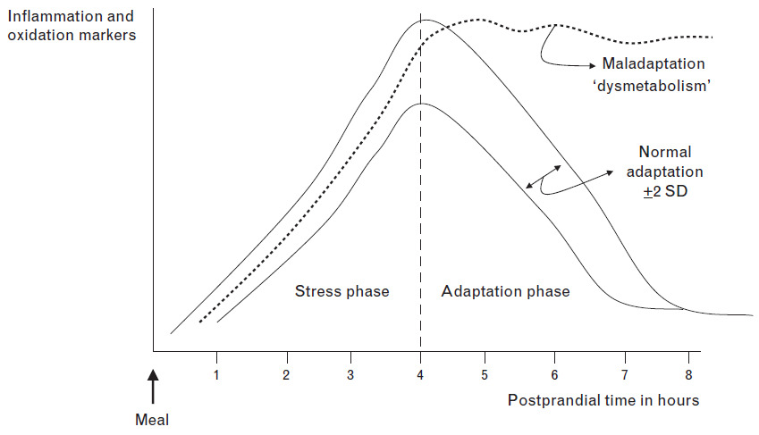

Figure 1. Adaptation to meal consumption-induced stress and dysmetabolism (Margioris, 2009)

