***Journal of Gazi University Health Sciences Institute***

**journal homepage*:*** <https://dergipark.org.tr/tr/pub/guhes>

**Title of The Manuscript (Times New Roman 12 pt, Max 20 Words,** **each word should begin with a capital letter (except for 'of', 'in', 'and', etc.)**

**Abstract**

Times New Roman 10 pt (Maximum 250 words)

Abstract should be written in paragraph form without being divided into headings.

Only English summaries should be written.

***Keywords:*** *keyword1, keyword2, keyword3, keyword4, keyword5 (According to MeSH index) (Alphabetical order, If it's a proper noun, capitalize the first letter; if not, use lowercase for the first letter.)*

1. **Introduction**

Times New Roman 11 pt

1. **Materials and Methods**

Times New Roman 11 pt ***(The information in the Material Method section of the journal writing rules should be included).***

**2.1. Subtitle (if necessary)**

Times New Roman 11 pt

1. **Results**

Times New Roman 11 pt

1. **Discussion**

Times New Roman 11 pt

1. **Conclusion**

Times New Roman 11 pt

**References**

Times New Roman 10 pt

DOI number should be given with https extension

Al-Ramadhani, G.O., & Al-Mtioti S. (2019). Determination of mesalazine spectrophotometry based on the charge transfer complex n- π using reagent p-bromanil. Journal of Education And Science, 28 (2), 71-84. http://dx.doi.org/10.33899/edusj.2019.161178

Altayib, F., Abdalla, A., & Elbashir, A.A., (2014). Development and validation of spectrophot-ometric methods for the determination of mesalazine in pharmaceutical formulation. Medicinal Chemistry, 4 (3), 361-366. http://dx.doi.org/10.4172/2161-0444.1000166

*Figures and tables should be added to single-column pages at the end of the article, with a table/figure on each page (as below).*

**Table 1.** The most purchased foods with the effect of advertising

|  |  |  |  |  |
| --- | --- | --- | --- | --- |
| **Food Group** | **Male** | | **Female** | |
|  | **n** | **%** | **n** | **%** |
| Meat and meat products | 57 | 18.1 | 47 | 6.4 |
| Milk, yoghurt etc. | 35 | 11.1 | 64 | 8.7 |
| Fruit and vegetable | 8 | 2.5 | 20 | 2.7 |
| Cereals, legumes | 3 | 1.0 | 12 | 1.6 |
| Fats | 5 | 1.6 | 5 | 0.7 |
| Fast food | 81 | 25.7 | 157 | 21.4 |
| Chocolate, biscuit, cake | 105 | 33.3 | 407 | 55.4 |
| Soft drink | 21 | 6.7 | 23 | 3.1 |
| Total | 315 | 100 | 735 | 100 |

**Table 2:** Comparison of study and control groups in terms of biochemistry laboratory examination results; non-parametric data

|  |  |  |  |
| --- | --- | --- | --- |
|  | **Autism Group N=30**  **Mean Rank** | **Control Group N=30**  **Mean Rank** | **p-value** |
| **ALT (U/L)** | 27.23 | 19.43 | 0.049* |
| **TSH (µIU/mL)** | 18.64 | 18.36 | 0.938 |
| **Ferritin (ng/ml)** | 18.68 | 17.55 | 0.749 |

**Table 3:** Parameters for Power-Law equations at two different temperatures, 25 °C and 32 °C.

|  |  |  |  |  |  |
| --- | --- | --- | --- | --- | --- |
| **Power-law** | | **Commercial product** | **20%poloxamer**  **+5%PG** | **20%poloxamer**  **+2,5%PG** | **25%poloxamer**  **+5%PG** |
| 25 °C | K±SE | 19.147 ± 0.015 | 194.044 ± 0.021 | 676.993 ± 0.069 | 759.018 ± 0.019 |
| n±SE | 2.378 ± 0.053 | 0.851 ± 0.020 | 0.401 ± 0.029 | 0.453 ± 0.009 |
| R2±SE | 0.997 ± 0.014 | 0.860 ± 0.037 | 0.918 ± 0.048 | 0.990 ± 0.016 |
| 32 °C | K±SE | 10.285 ± 0.049 | 1734.156 ± 0.072 | 975.752 ± 0.109 | 5271.550 ± 0.111 |
| n±SE | 2.086 ± 0.137 | 0.390 ± 0.020 | 0.418 ± 0.038 | 0.251 ± 0.015 |
| R2±SE | 0.972 ± 0.048 | 0.957 ± 0.029 | 0.865 ± 0.064 | 0.947 ± 0.055 |

’K’is the consistency index of power law equation,’ n’ is the flow behavior index, ‘R2‘is coefficient of determination,’SE’ is standard error

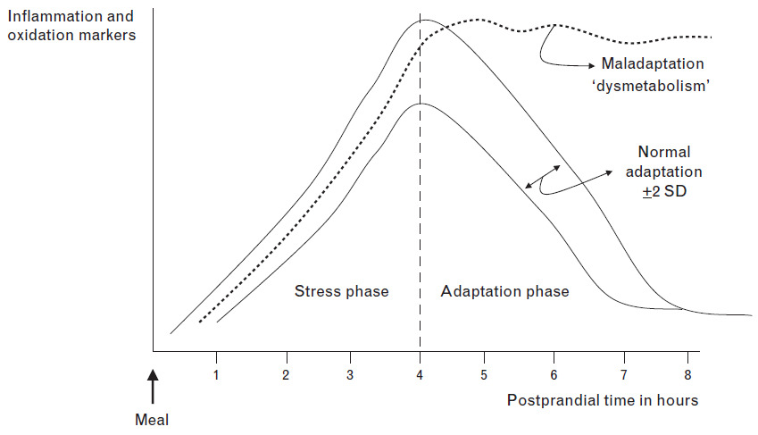

**Figure 1.** Adaptation to meal consumption-induced stress and dysmetabolism (Margioris, 2009)