GAZI UNIVERSITY

SOCIAL WORK STUDIES APPLICATION AND RESEARCH CENTER/

2022 ANNUAL ACTIVITY REPORT

Table of Contents¹
UNIT / SENIOR MANAGER PRESENTATION 3
- GENERAL INFORMATION 4
  - Mission and Vision 4
  - Powers, Duties and Responsibilities 4
  - Administration Information 4
    - Physical Structure 4
    - Organization Structure 10
    - Technology and Information Infrastructure 10
    - Human Resources 12
    - Services Offered 18
    - Management and Internal Control System 22
  - Other Considerations 22
- PURPOSE and TARGETS 23
  - Key Policies and Priorities 23
  - Objectives and Objectives in the Strategic Plan of the Unit 23
  - Other Considerations 23
- INFORMATION AND EVALUATIONS OF ACTIVITIES 24
  - Financial Info 24
    - Budget Implementation Results 24
    - Mali D entetim Results 25
    - Other Considerations 25
  - Performance Information 26
    - Activity and Project Information 26
    - Evaluation of Performance Program Results 30
    - Strategic Plan Evaluation Tables 35
    - Evaluation of the Performance Information System 35
    - Miscellaneous 35
- ASSESSING CORPORATE CAPABILITY AND CAPACITY 36
  - Advantages 36
  - Zayıflıklar 36
  - Assessment
36
- RECOMMENDATIONS AND MEASURES 37

¹ Headings that cannot provide information and data due to the field of activity of the unit may be removed from the report.

UNIT / SENIOR MANAGER PRESENTATION
With the publication of our regulation in the Official Gazette No. 31606 on September 22, 2021, our center was officially established under the name of Gazi University Social Service Studies Application and Research Center (SOHMER) and started to operate after the personnel appointment was realized . The Center has focused its activities on trainings, conferences and projects aimed at developing the field of social services.

8 undergraduate students studying in the 4th year Social Work Department of the Center completed their internships within the scope of the Spring Semester Applied Course.

In this context, between 03.02.2022 and 05.02.2022, " Child-Centered Play Therapy Training" was held at Gazi University Faculty of Health Sciences under the instructorship of Social Worker Gürcan BAL from the Ministry of Family and Social Services. In the training attended by the students of Gazi University Department of Social Work, the change, development, basic principles and principles of child-centered play therapy from the date of its emergence to the present day were discussed and the eorik narrative with case examples Supported.

On 22.02.2022, which was carried out with a participatory approach in line with the objectives of the formation of the Center, Mamak Municipality and the social responsibility project titled "Our Work Is Precious" which included the Painting Competition, Promotion Program and Seminar applications as a stakeholder. has been realized. In this context, with the cooperation made with Mamak Hoca Ahmet Yesevi Secondary School, vocational promotion was made to the students who continue their education at the 8th grade level of secondary school, especially to the professional personnel whose reputation was found to be low within the framework of scientific analyzes made in the field ; A painting contest named "I Know the Professions" was organized, and by creating an agenda in digital media through posters and videos, the importance of each profession was understood and contributed to increasing the reputation and value it sees in society. In the case of Mamak Municipality; A seminar called "Communication Styles" was organized to contribute to the knowledge of communication styles used in interpersonal relations for personnel who take an active role in municipal management and to enable them to increase their job performance.

Center director Assoc.Prof.Dr. "Professional Development Workshops: Theory Studies" activity was started by Ömer Faruk CANTEKİN for 9 undergraduate students . The studies started on 28.02.2022 are continuing in line with the goal of education and training of social work and the students are informed about social work theories. and skills.

In parallel with the targets determined within the Center , "Book Analysis Workshop" was held on 28.02.2022-10.06.2022. In this workshop, together with 33 undergraduate students studying in the Department of Social Work at Gazi University, time management and self-management skills , qualified reading, summarizing and analysis skills, presentation skills, developing active listening skills; comprehending the place of social work in our culture, evaluating the applications of theoretical courses and strengthening the professional identity The workshop, which has significant gains in terms of personal development, was carried out interactively.

On 03.03.2022, the Spring Semester Opening Conference was held, our Rector Prof. With the participation of Dr. Musa Yıldız, we hosted the Presidential Social Assembly at our university.

Prof. Dr. Vedat Işıkhan, Deputy Chairman of the Policies Board, held his conference on "Social Policy and Social Work in Our Country". In this context, the development of the concept of social work, the place of social work in our country and in the world, social policy and current studies on social work were conveyed.

On 02.03.2022 regarding the projects to be participated in line with our targets Assoc. Prof. Dr. Omar Alex CANTEKİN Management 1 high license Student 8 Intern license Student project meetings have been held with Mer on 10.03.2022times Assistant Manager Lecturer, Make. Ihsan ESEN’in of with the participation of project application Process and digits For necessary Reviews by project within the scope of to be discarded Steps activity Plan Conducted. In this context, TÜSEB Research and Development Projects Support Program within the scope of ‘’B Group AR-GE Project Call''named Project application Made.

Center Director Assoc. Prof. Dr. Ömer Faruk Cantekin held a "Positive Psychology Practices and Personal and Professional Development Seminar" on 11.03.2022 and 24.03.2022 . Social Work, Guidance and Psychological Counseling, Child Development and Special Education departments of different universities in Ankara province 3. And 4. In the seminar attended by class students; After the theoretical background of positive psychology applications were introduced, the necessary directions were made to the group participants to experience the applications. After the experience of positivityf psychology applications, the seminar was completed after the experience sharing after each application was carried out with the active participation of all the listeners.
"A Day of a Social Worker's Talk", which was organized specifically for the World Social Service Day within the body of our center , was held on 18.03.2022. The program was completed with the questions and answers about the topics that the future social worker candidates are curious about, following the transfer of Social Worker Emre BALCI's experiences in the profession.
On 04.04.2022, within the scope of the European Union Civil Thinking Program, "Awareness of Mental Health: Digital Liberation Days!" project application has been made.
On 12.05.2022, in the conference hall of Gazi University Faculty of Health Sciences, to convey the historical processes of the use and development of music as a preventive and healing method from past to present, to enable participants to perceive themselves and others as a perfect instrument and to use music as a supportive tool in coping with the difficulties in daily life. "Music Therapy Screening" was held in order to experience the effects of music on physical and mental health in order to develop the skills of illumination and to experience the effects of music on physical and mental health.

In order to contribute to professional development, to increase the accumulation of practice, to share experience and to gain experience with a supervisor, together with the Social Service Community on 13.05.2022, "Family Studies I: In Family Therapy" A seminar based on the application of "Techniques Used" was held.
Between 14.07.2022 and 22.09.2022, every week activities that develop the person in bio-psycho-socio-spiritual dimensions are introduced practically and together with the group, feelings, thoughts,

10 volunteers participating in a 10-week Personal Development Times event where experiences are shared
completed with the student .
On 15.09.2022, the Social Policies Board meeting was held at Çankaya Mansion with the agenda of "Presentation of Social Assistance from Micro to Macro". Deputy Chairman of the Presidential Social PoLitikalar Council Prof. The meeting, chaired by Dr. Vedat Işıkhan, was completed with the presentation of Şanlıurfa ASH Provincial Director Hasan Bilici and the contributions of SOHMER.
Gazi University SOHMER has adopted a management approach that uses its physical and economic resources effectively in accordance with the Public Financial Management and Control Law No. 5018 and that does not depart from transparent, accountable, scientific and ethical values in order to achieve the objectives specified in the strategic plan of Gazi University . In this direction, SOHMER aims to have a central structure that will make the total quality and success it has achieved in the activities to be carried out continuous .

Assoc. Prof. Dr. Ömer Faruk CANTEKİN

Center Director

- GENERAL INFORMATION

Mission and Vision Mission
Our mission as Gazi University Social Work Studies Application and Research Center is; To identify the unmet needs related to social welfare at the level of individual, family, group, community, organization and society and to plan and realize education, research and applications that will contribute to the solutionof social problems , social policy to contribute to the construction processes with scientific data.

Vision

As Gazi University Social Work Studies Application and Research Center, our vision is; the needs of social work in the fields of education, research and application in line with social service principles, standards, values and practices, and the adequacy of the services currently provided to conduct scientific research in order to determine and develop new service policies, to contribute to the development of the social work profession and field.

Powers, Duties and Responsibilities

- To conduct scientific research in order to determine the needs of social work in the fields of education, research and application, the adequacy of the services currently provided and to develop new service policies .

- To plan projects in cooperation and coordination in line with the needs of public institutions and organizations, private organizations and non-governmental organizations operating in the fields covered by social service, and scrounge.

- To cooperate with public institutions and organizations or private organizations operating in the country or abroad related to the field of study within the scope of the provisions of the relevant legislation.

ç) To provide scientific consultancy to public institutions and organizations or private organizations working in the fields of social services.

- To organize various in-service training programs aimed at refreshing the knowledge of the personnel working in the fields of social services in line with new scientific data and increasing their work efficiency.

- National and international conferences, panels, workshops on issues related to the field of study,
to plan and carry out seminars, symposiums, congresses and similar scientific activities .

- To plan and carry out certificates, courses and similar training programs in the fields of social work.

- To carry out mass media activities aimed at increasing social awareness by contributing to the publication of programs related to social work in local and national mass media.

ğ) To publish periodicals and books such as bulletins, journals, scientific journals, to publish reports in the field of social policy.

- The latest developments and innovations in the fields of social work are covered by translation studies.
transfer.

ı) To carry out other activities in line with the objectives of the Center.

Article 9 of the central regulation The duties of the director in the article are as follows:

- To represent the Center, to call the Board of Directors and Advisory Boards to a meeting, to chair these Boards .

- To implement the decisions taken by the Board of Directors.

- To carry out the administrative affairs of the Center, to carry out its correspondence, to provide the necessary coordination and supervision. ç) To ensure coordination regarding the implemented programs and activities .
- To submit the annual budget, activity report and work program for the following year to be prepared by the Board of Directors of the Center to the approval of the Rector.

- To determine and supervise the distribution of duties and working principles of the personnel working in the center .

Administration Information

Physical Structure

Service Areas
Currently, our center director Assoc. Prof. The room allocated to Dr. Ömer Faruk CANTEKİN at the Faculty of Health Sciences is also used in the conduct of the center's activities.

Organizational Structure

The management staff of the center consists of the center director, deputy director and board of directors .

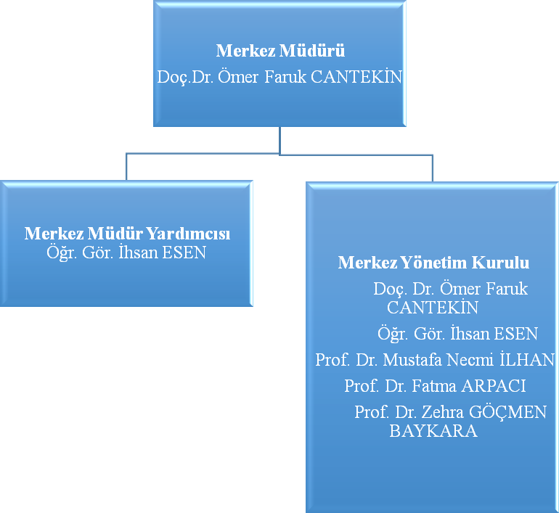

Technology and Information Infrastructure 3.1.Software and Information Systems 3.2.Computers
  - Library Resources

Other Information and Technological Resources
Currently, our center director Assoc. Prof. The desktop computer and personal printed resources allocated to Dr. Ömer Faruk CANTEKİN at the Faculty of Health Sciences are also used in the execution of the center's activities.

People

4.1 Academic Personnel
Academic Personnel
 | According to the Occupancy Rate of the Positions |  |  | To the Employment Style of the Cadres  According to
 | Full | Empty | Sum | Full Time | Part Time
Professor | 3 |  | 3 |  | 3
Professor | 1 |  | 1 |  | 1
Asst. Prof. Dr. Member | - |  |  | -
Instructor | 1 |  | 1 |  | 1
Research Assistant | - |  |  | -
Sum | 5 |  |  | - | 5

Services Offered

  - Training Services
8 undergraduate students studying in the Social Work Department of the Faculty of Health Sciences within the center completed the spring semester internship process within the scope of the applied course.

Associate and Undergraduate Student Numbers

Number of Students
Name of the Unit | I. Teaching |  |  | II. Education |  |  | Remote  Education |  |  | Sum |  | Grand Total
 | And | K | Top. | And | K | Top. | And | K | Top. | Daughter | Male
Faculties | 1 | 7 |  |  |  |  |  |  |  |  |  | 8
Schools
Profession
Colleges
Sum | 1 | 7 |  |  |  |  |  |  |  |  |  | 8

Healthcare
There is no health service in the center.

Administrative Services

The center has no working capital income. Research and therefore expenditures are carried out within the scope of research projects and are realized with the approval of the Board of Directors of the Center.

Management and Internal Control System
The unit's decision-making processes such as appointment, purchase, tender, authority and responsibility structure, financial management, pre-expenditure control system are determined and evaluated by the General Secretariat of Gazi University .

Other Considerations
(Under this heading, other issues that are not included in the above headings but that the unit deems necessary to explain are indicated as a summary.)

AIMS and OBJECTIVES

Key Policies and Priorities
(The policy documents to be taken as basis vary according to the field of activity of the public administration and the sector in which it is located. Units should take into account the parts of the top policy documents listed below as examples related to unit activities .
  - Presidential Annual Programs
  - Development Plans
  - New Economy Program (Medium Term Program)
  - "Turkey's Higher Education Strategy" Prepared by the Council of Higher Education
  - Our University Policies
  - Strategic Plan of Our University)

Objectives and Objectives in the Strategic Plan of the Unit
(The aims and objectives in the unit strategic plan are included.)

Strategic Objectives | Strategic Objectives
Strategic Objective-1: In the field of social work | Goal-1: To receive project writing training
developing projects that will contribute
 | Target-2: Public institutions and organizations | related
 | projects related to the field | benefit
 | Applying for projects that will provide
Strategic Objective-2: Active learning | Goal-1: Our university within our center
bachelor's and master's degree | advising undergraduate and graduate students
the professional qualifications of its students | regarding the steps to be taken in the process by providing the service
development | role assignment and parallel in-service trainings
 | Editing

 | Goal 2: Planning and conducting certificates, courses and similar training programs in the fields of social work
Strategic Objective-3: Strengthening the institutionalization of the center within the framework of national and international norms | Goal-1: Increasing the number of activities that will strengthen the sense of belonging of graduate and active students
 | Objective-2: Planning and conducting conferences, panels, workshops, seminars, symposiums, congresses and similar scientific activities on topics related to the field of study
Strategic Objective-4: Conducting qualified and high value-added research and development activities that will strengthen the vision of the Research Center | Objective- 1: To increase the participation of academic staff and undergraduate and graduate students in research studies in the field of social work
 | Objective- 2: Conducting scientific research in order to determine the needs of social work in the fields of education, research and application, the adequacy of the services currently provided and to develop new service policies

Other Considerations

INFORMATION AND EVALUATIONS ON ACTIVITIES

Financial Information
The center has no working capital income. Expenditures due to research are made within the scope of research projects and are realized with the approval of the Board of Directors of the Center.

Performance Information

( Article 26 of the Regulation on Procedures and Principles Regarding Strategic Plans and Performance Programs and Activity Reports to be Prepared by Public Administrations Under the heading of Performance information in accordance with the article; the results of the evaluation of the unit's strategic plan and the information and evaluations regarding the realization of the performance indicators in the performance program and for which the unit is responsible and the activities carried out are included.)

Activity and Project Information

(Under this heading, detailed explanations of the activities and projects carried out in the relevant year and their results will be included).

    - Activity Information

1.1.1. Scientific Meetings , Events

DEPARTMENT NAME | Sempozyu m |  | Convention |  | Conference |  | Panel |  | Seminar |  | Other* Events |  | Grand Total
 | A | B | A | B | A | B | A | B | A | B | A | B
 |  |  |  |  | 1 |  |  |  | 8 |  | 5
A: National, B: International

* Other activities will be listed below.

Other Events | Number
Open Session
Chat
Theater
Concert
Sergius
Tournament
Field Trip
Training Seminar | 8
In-Service Training Program | 2
Social Responsibility Project | 1
Conference | 1

    - Project Information
Number of Scientific Research Projects
 | 2022
PROJECTS | Previous  Years  Project from Circuit | Most Projects Added to the Year | Topl on | Completed Project During the Year | Topl am Öden ek  TSP | Collect m Spend  TSP
TC CSBB
TUBITAK
OFF |  | 1
SCIENTIFIC RESEARCH PROJECTS |  | 1
OTHER
SUM |  | 2

CHILD CENTERED GAME THERAPY TRAINING

"Child-Centered Play Therapy Training" was held between 03.02.2022 – 05.02.2022 at Gazi University Faculty of Health Sciences under the instructorship of Social Worker Gürcan BAL from the Ministry of Family and Social Services. In the training attended by the students of Gazi University Department of Social Work, the change, development, basic principles and principles of child-centered voting therapy from the date of its emergence to the present day were discussed and the theoretical expression was supported with case examples. During the training period, the training was completed at the end of three days after the participants obtained the experience of practicing child-centered play therapy through fictional events from time to time in groups and sometimes individually .
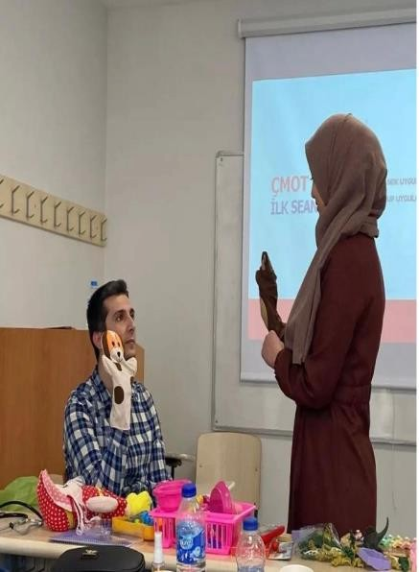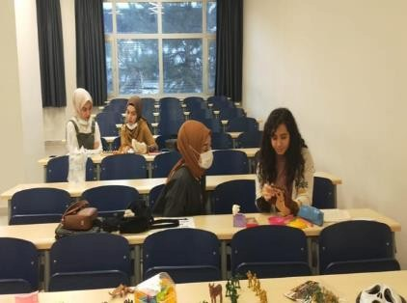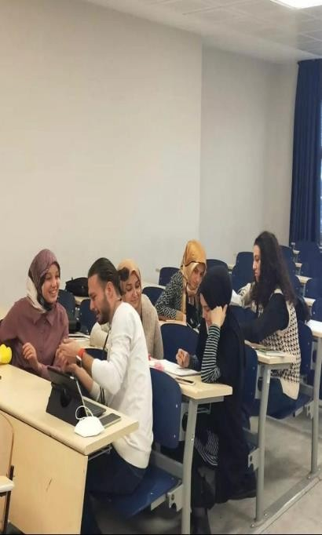

OUR JOB IS SWEAT , EVERY BUSINESS IS A VALUABLE SOCIAL RESPONSIBILITY PROJECT

The social responsibility project titled İşimiz Alın Teri, Her İş Kıymetli, which was completed between 22 February and 19 April in partnership with Gazi University Social Work Application and Research Center (SOHMER) and Mamak Municipality, Mamak Hoca Ahmet Yesevi Secondary School to raise awareness about the professions for children studying in the 8th grade, and to ensure that every profession is a society. professional promotion structures to awaken the awareness that they have an important function in it and contribute significantly to the social functioning; A painting contest named "I Know the Professions" was organized, and by creating an agenda in digital media through posters and videos, the importance of each profession was understood and contributed to increasing the reputation and value it sees in society . In the case of Mamak Municipality, to contribute to the knowledge of the communication styles used in interpersonal relations to the personnel who take an active role in the management and to enable them to increase their job performance . A seminar called "Communication Styles" was organized.

WEEK

The first week of the project covers the period from 22 February to 1 March 2022. The main activity of the first week is the determination of the project topic, its definition, decision-making and the establishment of the project team.

Project Subject

Developed project; will ensure that awareness is created in the society in connection with the relevant theme such as seminars, competitions, using digital publishing tools in line with the needs stated in the literature and the news reflected in the public opinion regarding the professions with low reputation, It has a subject that includes communication channels that will guide the increase of working performances and support the strengthening of social integrity.

Project Coordinator

Assoc. Prof. Dr. Ömer Faruk CANTEKİN

Project Consultant

Prof. Fatma ARPACI, MD

Project Team

Fatma Rümeysa TAŞBAŞ Tuğçe BUL
Meryem ORHAN Kadriye OKUR Nazlı Hilal OKATAN Zehra UÇAR
Hüsamettin ÇELEBİ Merve EYİL
Zeynep SARIYILDIZ

WEEK

The second week of the project covers the dates of 1-8 March 2022. Within the scope of the project subject determined in the second week of the project, the project purpose, objectives and outputs were determined.

Project Objective

Scientific studies in the relevant field emphasize the importance of the fact that children should be aware of their own cultures and the society they live in should be gained by educational institutions and organizations. In the social responsibility project named "Our Work is Sweat, Every Work is Precious", the general purpose is to provide professional awareness to children at the primary school level through ways such as painting competitions and interactive expressions, and to provide vocational awareness to the society offered by the professions to draw attention to the contribution, to raise awareness of social integrity; to create an agenda in digital media through posters and videos that each profession contributes to our society in various ways, and after the importance of each profession is understood and the reputation and value it sees in the society is increased, the words and to influence the authorities in the context of policy and service making processes. As a special purpose in the project

With the seminar to be held for the personnel who take an active role in the management of Mamak Municipality, it is aimed to increase their business performance by contributing to the knowledge of communication styles used in interpersonal relations.

Project Objective

It is aimed to raise awareness of the residents and children of the Mamak region about the professions and to awaken the awareness that each profession has an important function in the society and provides significant contribution to the social functioning. In the case of the municipality, it is envisaged that the communication skills and functionalities of the Mamak Municipality professional personnel will be increased, and that the professional interventions they have made will carry out more systematic studies by increasing the level of benefit and effectiveness on the community and the municipality.

WEEK

The third week of the project covers the dates of 8-15 March. The third week covers the formation of the plan of the project . The implementation date of the project has been determined as 7 April 2022 with the joint decision of the project team. Within the scope of the project, the institutions and organizations to be collaborated have been determined. In addition, project banners and contents are designed.

WEEK

The fourth week of the project covers the dates of 15-22 March 2022. It covers preliminary work in line with the plan created in the third week. Information was collected about the necessary institutions and organizations in order to find the right place for the project implementation. As a result of the researches, the institutions and organizations where the project will be implemented have been determined. Research has been carried out on the necessary permissions and requests for the application. The institutions and organizations to be jointly studied in the third week of the project were contacted by SOHMER, Faculty of Health Sciences. Ankara Mamak District Municipality was contacted for the project implementation.

Then, from Gazi University Health, Culture and Sports Department ;

A letter should be written to the Ministry of National Education (MEB)-Ankara Provincial Directorate of National Education about the implementation of Mamak Hoca Ahmet Yesevi Secondary School, which is mentioned in the project in question ,

Ensuring that team members reach the point where the project will take place,

Mamak Municipality organized within the scope of the project "I Know the Professions" from the students who participated in the painting contest named 1. tablet to student, 2. Smart watch to the student 3. Gifting bluetooth headphones to the student,

Issuance of participation certificates to the members involved in the project,

The project was requested to be printed on posters and published on billboards.
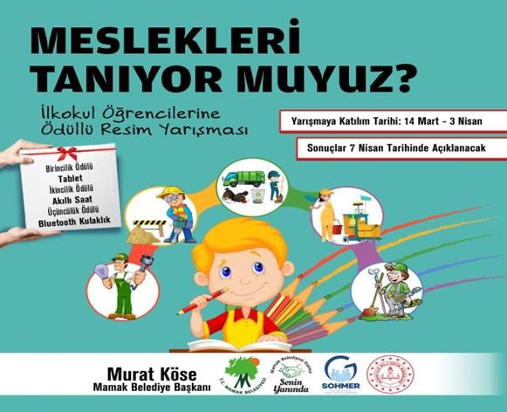
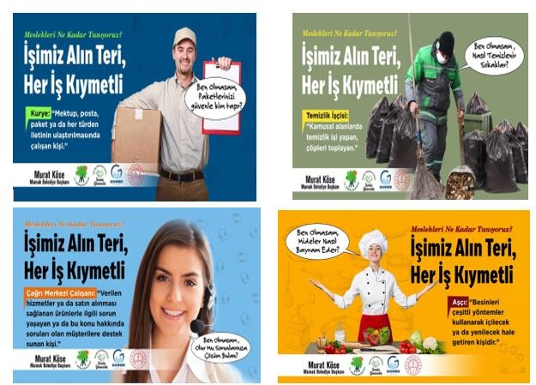

WEEK

The fifth week of the project covers the dates of 22-29 March 2022. The fifth week covers the process of obtaining the necessary permits for the application and meeting the demands. In addition, regarding the publication of the posters within the implementation steps of the project, the SOHMER team contacted the professional staff of the Mamak Municipality and consulted on the slogans that could raise public awareness about the posters to be published on the billboards and worked on the printing process.

WEEK

The sixth week of the project covers the period from 29 March to 5 April 2022. In this week, the necessary permissions obtained for the painting competition at the project stages were realized through the media and school administrations in the primary schools determined within the scope of the project in line with the cooperation with the Mamak District Directorate of National Education. The works of the students who were entitled to be evaluated in accordance with the directive determined for the painting competition were submitted to SOHMER for evaluation after the information about the owners was recorded by the Provincial Directorate of National Education and the official procedures were fulfilled .

WEEK

The seventh week of the project covers the dates of 5-12 April 2022. In this week , the evaluation of the works received from the Mamak District Directorate of National Education was evaluated within SOHMER and the relevant institutions were contacted about the announcement of the winning students. In addition, the professional personnel employed in low-reputation professions within the scope of the project and the members of the SOHMER team will be able to provide Mamak Hoca Ahmet Yesevi Secondary School on 7 April 2022 with individuals from various professional milestones that are considered to be low in reputation, as well as the recognition of the professions by the students; to provide information about the duties performed by the members of the relevant professions and to increase awareness about these professions in total. professional promotion isrealized.

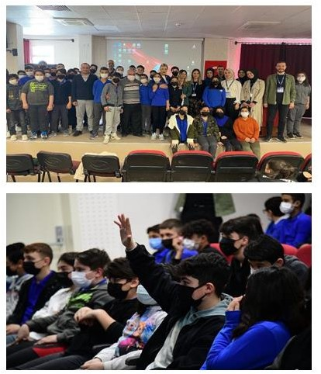

Mamak Municipality; In order to contribute to the knowledge of communication styles used in interpersonal relations for personnel who take an active role in municipal administration and to enable them to increase their job performance, Assoc. Prof. Dr. Performed by Ömer Faruk CANTEKİN.

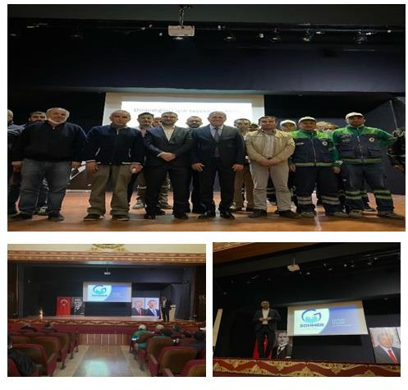

WEEK:

The eighth week of the project covers the dates of 12-19 April 2022. The winners of the competition this week were the Ministry of National Education Inspector Sait Türetken and District MEM Sn. It was presented by Mustafa Özel. It covers the process flow in line with the project objectives and the reporting process related to the project gains.
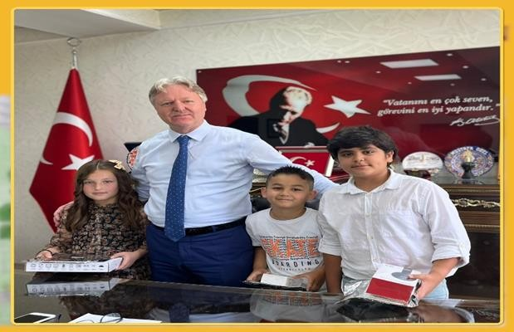
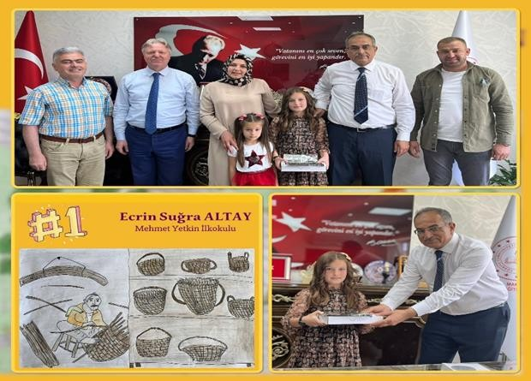

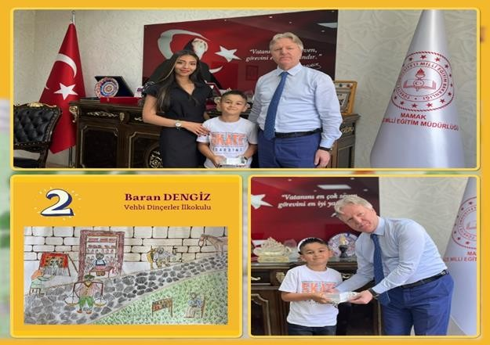

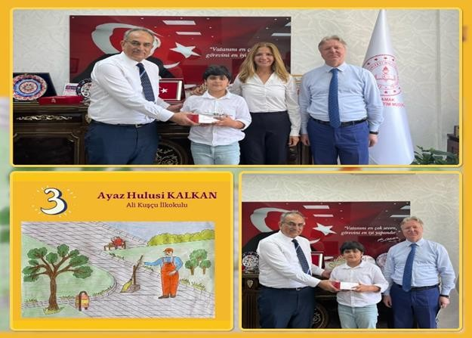

Justification of the Project, Identification of Needs and Problems

As a result of the news in the press and within the framework of the information received from parents and teachers and the observations made, it was seen that children did not have enough information about the professions. In his study in 1994, Semenoğlu stated that the fact that children learn the lifestyles of their own culture and society is a competence that should be gained in preschool education. With various teaching-learning activities to be organized in this learning process, it has included in the scope of research how each profession has an indispensable importance in the lives of society and individuals. From a different perspective, Yaylacı stated in his study in 2007 that the career development of individuals begins at the age of power, so that families, teachers, school administrators, children have a wider range of goals and desires. He stated that he should prepare the ground for shaping their future correctly.

In the study conducted in 2014 within the scope of the Social Structure Research Program, it was stated that the reputation shown to professions according to demographic (age, gender), cultural (education, political opinion), social (settlement, social status) and economic (income level) factors in individuals It is stated that the perception of reputation is formed according to the income or income obtained from the profession, job security, education on which the profession is based. However, every profession from cookery to doctor, from cleaning worker to engineer has functions that it performs in society and each profession contributes significantly to social functioning. For this reason, it is necessary to raise awareness in my society especially about the professions that are relatively less respected.

On the other hand, effective communication skills facilitate interpersonal relations in all kinds of human relations and all kinds of occupational groups. In his study, Korkut (2003) stated that communication-themed trainings should be widespread in workplaces. Determining the communication profile of the group or groups to be selected from the municipal administration personnel within the scope of the project constitutes an important step to be taken in this direction.

Project Results

Billboard posters emphasizing the importance and function of 10 professions with low reputation in terms of the social system in the scientific analysis studies carried out in the field were prepared and published.

Vocational promotion was made to the 8th grade students of Mamak Hoca Ahmet Yesevi Secondary School in Ankara, especially to the professionals whose reputation was found to be low within the framework of scientific analyzes made in the field .
A painting contest titled "I Know the Professions" was held for the 8th grade students of Mamak Hoca Ahmet Yesevi Secondary School in Ankara and the gifts of the children who received degrees in the competition were presented by the Ministry of National Education Inspector Sait Türetken and District MEM Mr. Mustafa Özel. "Communication Styles" seminar was held for Mamak Municipality professional personnel.

SOHMER DEPARTMENT OF SOCIAL WORK SPRING SEMESTER OPENING CONFERENCE

In the first event of the Spring Semester, as the Social Work Studies Application and Research Center (SOHMER), we hosted the Vice President of the Presidential Social Policies Council Prof. Dr. Musa Yıldız with the participation of our Rector Prof. Dr. Musa Yıldız. Dr. Vedat Işıkhan held his conference on "Social Policy and Social Work in Our Country". In this context, I have conveyed about the development of the concept of social work, the place of social work in our country and in the world, social policy and current studies on social work.
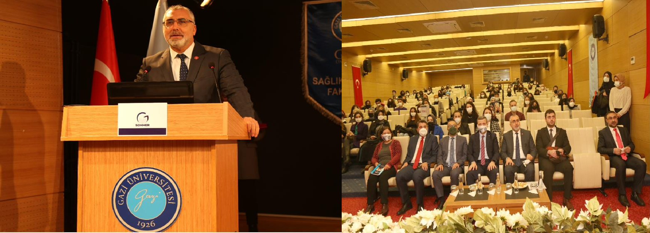
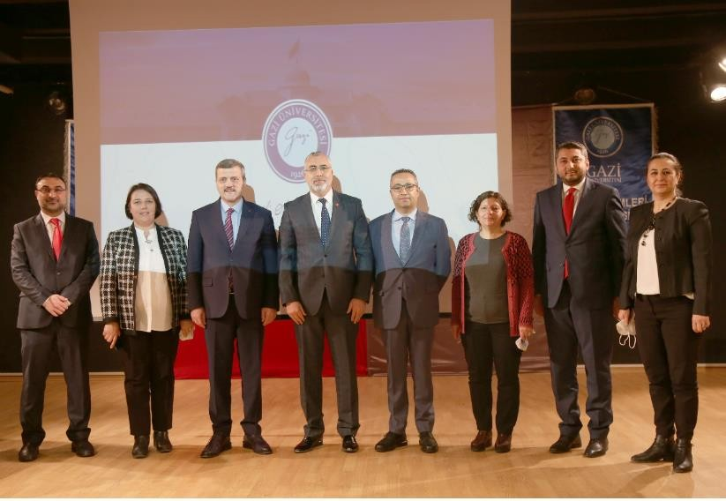

PROFESSIONAL DEVELOPMENT WORKSHOPS: THEORY STUDIES
Assoc. Prof. Dr. Ömer Faruk CANTEKİN, Director of the Center for "Theory Studies", has announced that 9 undergraduate students will have information about social work theories, gain perspective on the place and importance of social work in our culture, and be informed about various geographies and theories that have emerged in cultures since 28.02.2022. has been carried out since. These studies are carried out face-to-face 1 day a week.
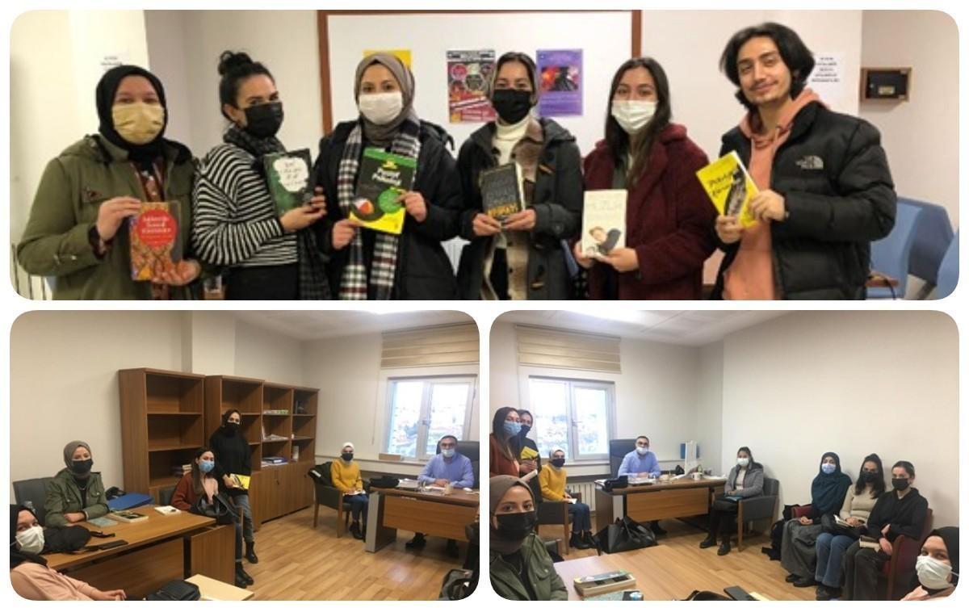

BOOK ANALYSIS WORKSHOP

In parallel with the targets set within the Center, a 10-week "Book Analysis Workshop" covering the months of November-January was held. In this workshop, 33 undergraduate students studying in the Department of Social Work at Gazi University participated in developing time management and self-management skills , qualified reading, summarizing and analyzing skills, presentation skills, active listening skills ; The workshop, which has important achievements in terms of personal development as well as strengthening the professional identity such as comprehending the place of social work in our culture, evaluating the applications of theoretical courses is interactive has been maintained as.
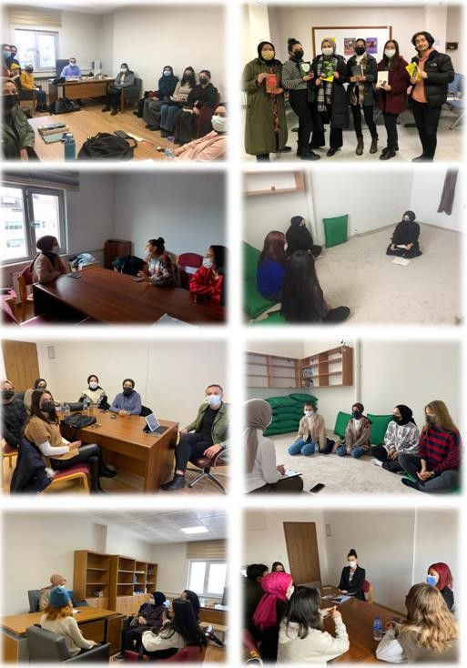

PERSONAL AND PROFESSIONAL DEVELOPMENT SEMINAR WITH POSITIVE PSYCHOLOGY PRACTICES I- II

"Personal and Professional Development Seminar with Positive Psychology Applications" was held on 11.03.2022 and 24.03.2022 at Gazi University Faculty of Health Sciences Conference Hall. Social Work, Guidance and Psychological Counseling, Child Development and Special Education departments of different universities in Ankara province 3. And 4. In the seminar attended by the class students , SOHMER Director and Gazi University Deputy Head of the Department of Social Work Assoc. Prof. Dr. Ömer Faruk CANTEKİN introduced the positive psychology applications together with their theoretical backgrounds and then the group led the way for the participants to experience the applications. After the experience of positive psychology practices, the seminar was completed after the experience sharing after each application was carried out with the active participation of all the listeners.
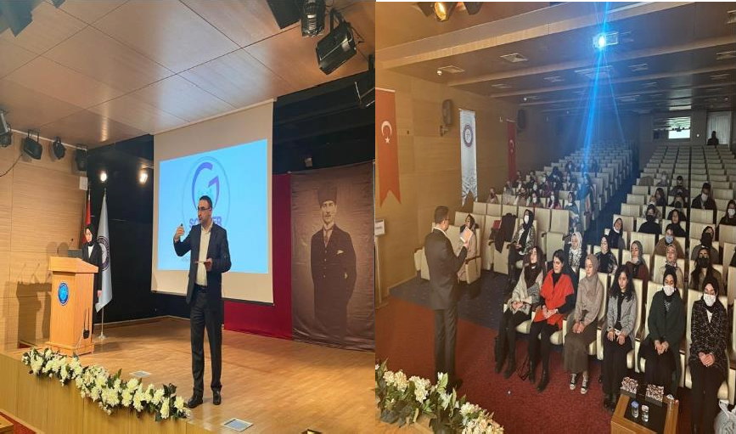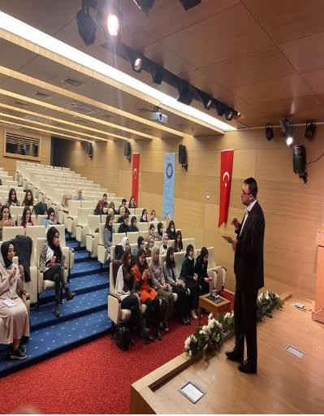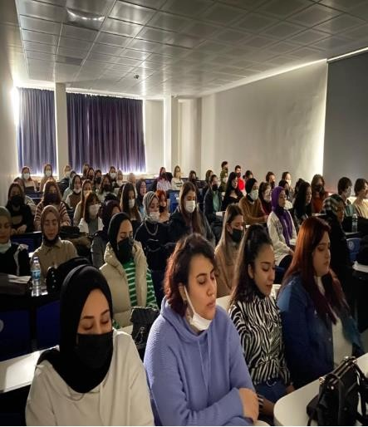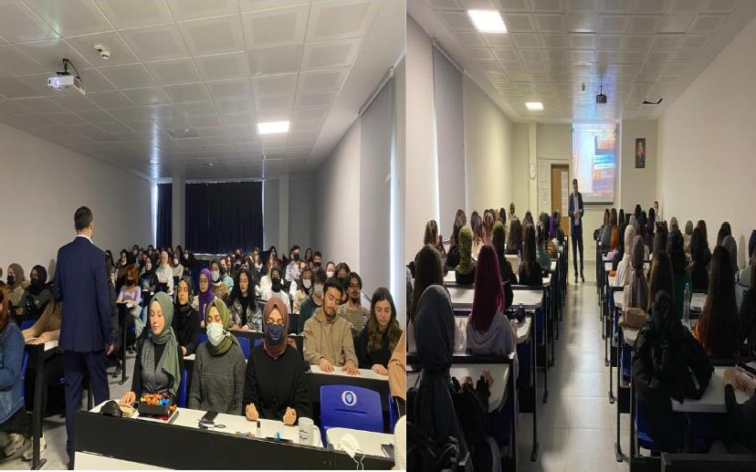

A DAY OF SOCIAL WORKER INTERVIEW

On Friday, March 18, "A Day of a Social Worker's Talk", which was organized specifically for the World Social Service Day, was held on 18.03.2022. The program was completed with the questions and answers of Social Worker Emre BALCI about the topics that the future social worker candidates are curious about, following the transfer of his experiences in the profession.
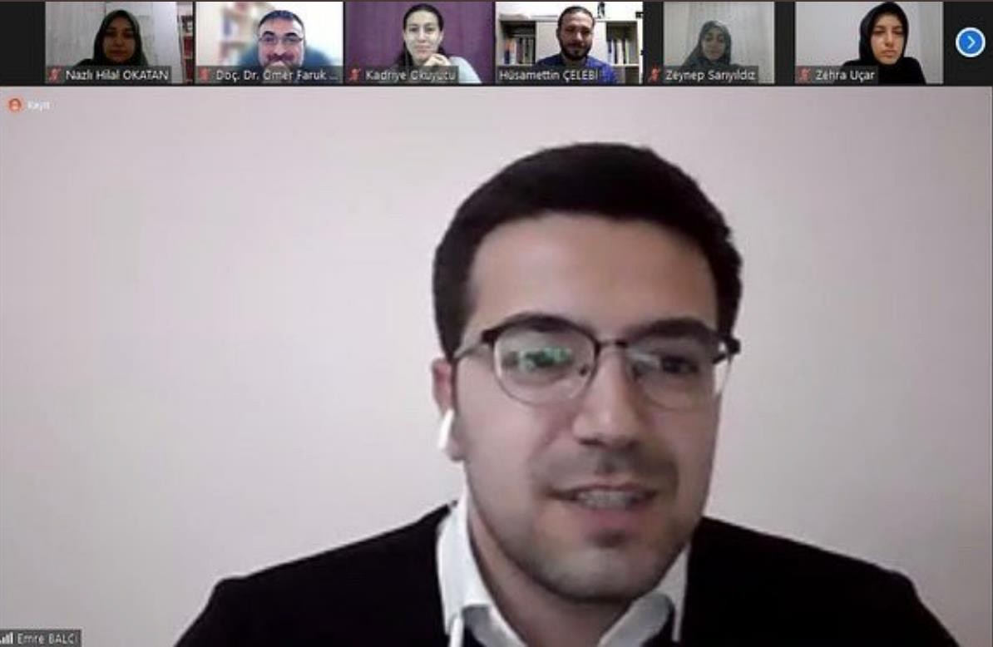
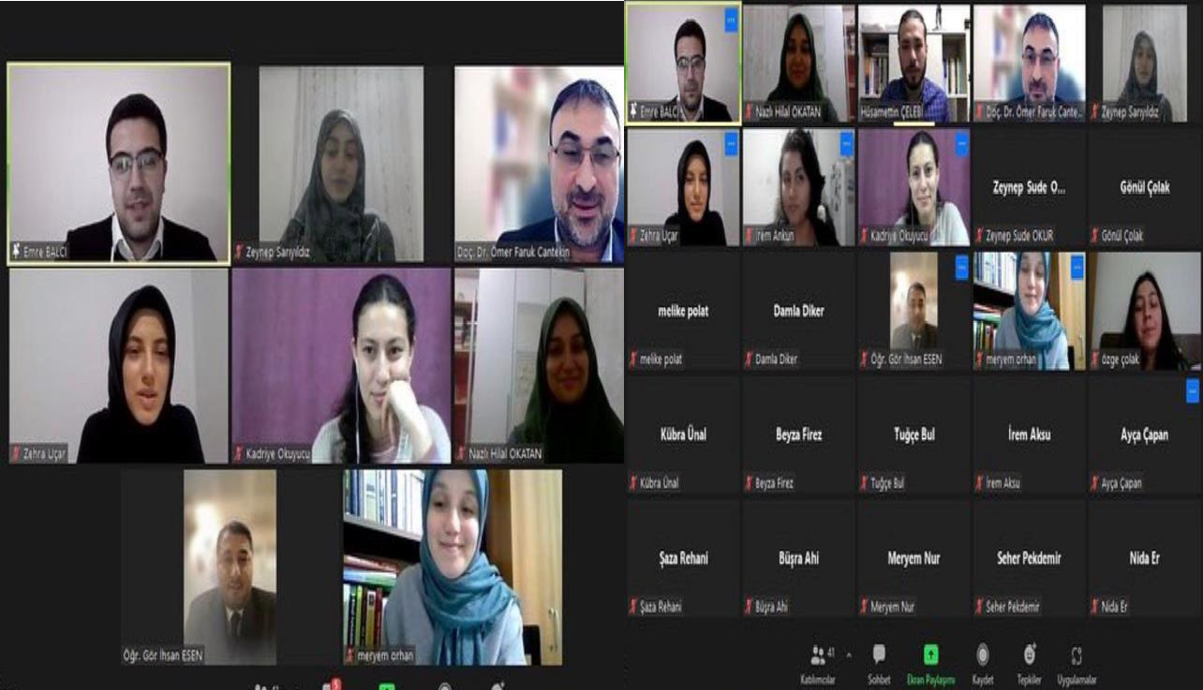

MUSIC THERAPY SCREENING

With the presentation of music therapy, the participants are informed about the historical processes of the use and development of music as a preventive and healing method from past to present, the participants' perception of themselves and others as an original instrument and the difficulties in daily life are overcome by the difficulties in daily life. "Music Therapy Screening" was held on 12.05.2022 at the conference hall of Gazi University Faculty of Health Sciences in order to develop the skills of using music as a supportive tool in terms of clarification and to experience the effectsof music on physical and mental health in this direction.
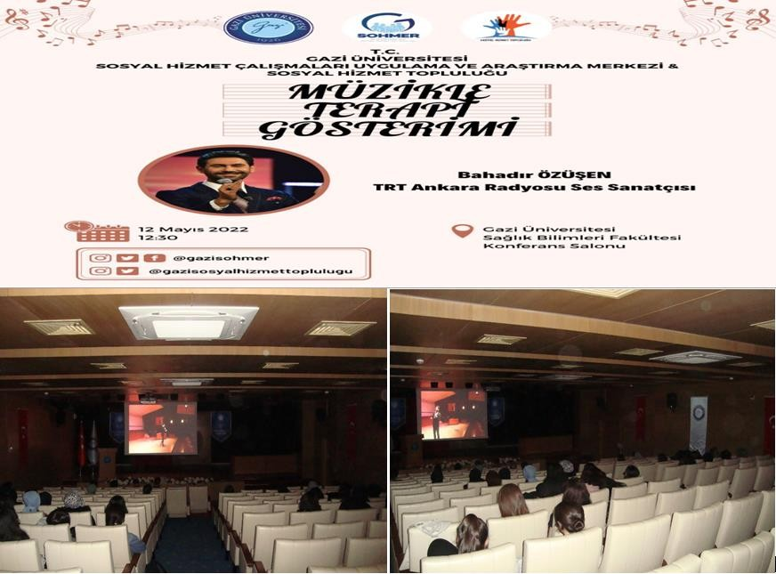

FAMILY STUDIES I: TECHNIQUES USED IN FAMILY THERAPY
In order to contribute to professional development, to increase the accumulation of practice, to gain experience with a supervisor through experience sharing, a seminar based on practice on "Family Studies I: Techniques Used in Family Therapy" was held on 13.05.2022.
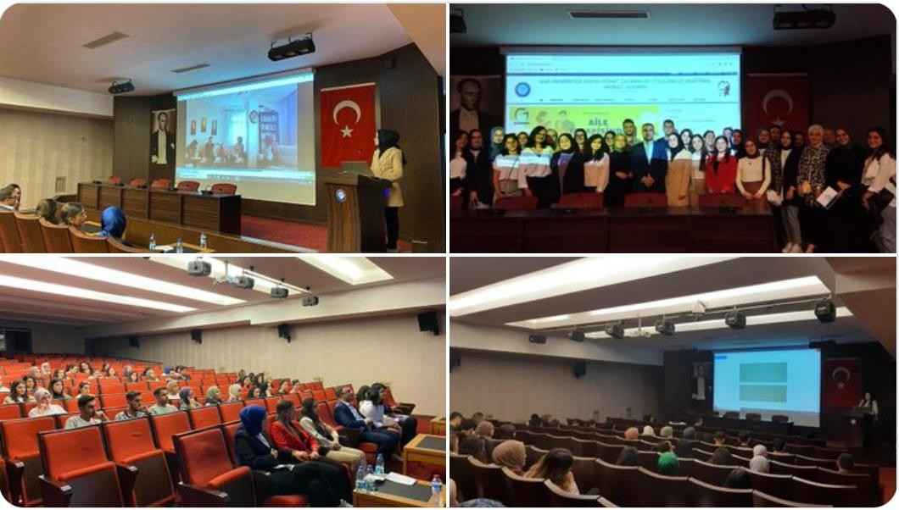

TIMES OF PERSONAL DEVELOPMENT
Between 14.07.2022 and 22.09.2022, every week we put the person on bio-psycho-socio-spiritual dimensions.
The development activities are:

  - Week:Transfer of Responsibility
  - Week:Mirror Practice
  - Week:Ten Fingers of Gratitude
  - Week: Relaxation and daydreaming
  - Week:This Person May Die Tonight
  - Week:Genuine Compliments
  - Week: Focus on What Matters
  - Week: Rhythmic Breath
  - Week: Smile
  - Week :Virtues of Secret Action

The applications were applied to individuals for 10 weeks, then feelings, thoughts and experiences were shared with the group. 10-week Personal Development Times activity was completed with 10 students who participated voluntarily.
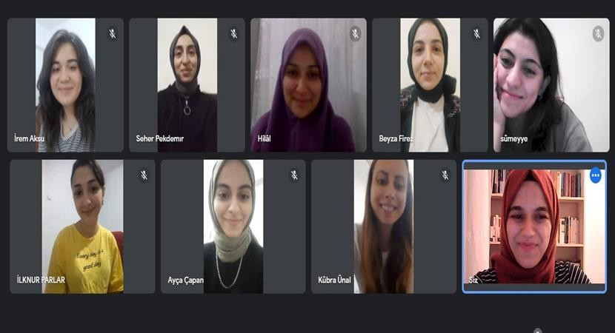

PRESENTATION OF SOCIAL ASSISTANCE FROM MICRO TO MACRO MEETING
On 15.09.2022, the Social Policies Board meeting was held at Çankaya Mansion with the agenda of "Presentation of Social Assistance from Micro to Macro". The meeting, chaired by Prof. Dr. Vedat Işıkhan, Deputy Chairman of the Presidential Social Policies Council, was completed with the presentation of Şanlıurfa ASH Provincial Director Hasan Bilicinin and the contributions of SOHMER.
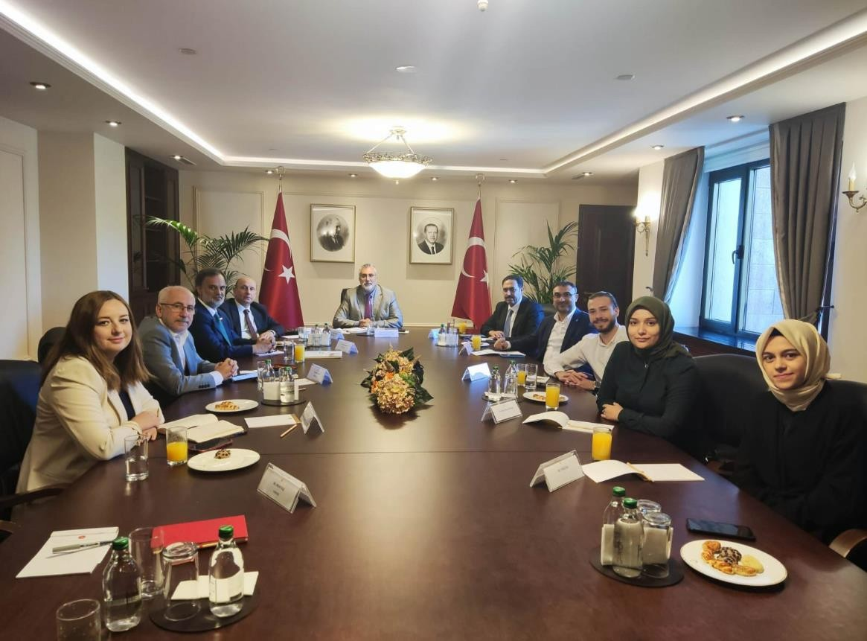

Evaluation of Performance Program Results
(The Performance Indicators in the 2022 Performance Program of our University, for which the Unit is responsible, are presented as a table below. Evaluations of their realization are included. In order to evaluate the performance results of our university, the data must be filled in by the responsible units for the whole of our university. Entering the data into the Corporate Data Management System for the purpose of tracking the data annually in the corporate infrastructure will also be requested in official writing ).

Performance Indicator | Unit of Measure | 2022 Year  End  Realization as of | Units Responsible for Indicators
Expenditure amount of projects supported by the Presidential Strategy and Budget Directorate (TL) | TSP |  | Research and Development Institution  Coordinator
2022 appropriation amount of the projects supported by the Presidential Strategy and Budget Department. | TSP |  | Strategy  Department of Development
Would-ge to ge the spent budget to the total budget Rate
Would-Give Projects sum Amount (TL) | TSP |  | Research and Development Institution  Coordinator
Total Budget Expense (TL) | TSP |  | Strategy  Department of Development
Revolving Capital Expenditure (TL) | TSP |  | Revolving Capital  Business Directorate
Would-give regarding the resulting products Received patent Number | Number |  | Research and Development Institution  Coordinator

Would-give Result ticarileştirilen product Number | Number |  | Research and Development Institution  Coordinator
Research centers revenue amount | TSP |  | Research and Development Institution  Coordinator
Number of projects carried out by research centers with industry | Number |  | Research and Development Institution  Coordinator
Number of research projects supported under BAP | Number |  | Research and Development Institution  Coordinator
Teaching Element per Falling would-give project Number
Sum Would-Give Number of projects | Number |  | Research and Development Institution  Coordinator
Total Number of Instructors | Number |  | Staff Apartment  Presidency
Number of patent, utility model and industrial design applications | Number |  | Research and Development Institution  Coordinator

By national and international organizations  Supported would-give Project Number | Number |  | Research and Development Institution  Coordinator
Number of scientific publications included in international indices | Number |  | Research and Development Institution  Coordinator
Number of activities related to social integration and inclusion for disadvantaged groups | Number |  | Social Affairs Institution Coordinatorship
Number of people applying to training programs | Number | 8 | Beltek, GAZİSEM, TÖMER,  Staff Apartment  Presidency
Number of activities carried out for graduates | Number |  | Social Affairs Institutional Coordinatorship, All Academic Units
Number of certificates issued by the Continuing Education Center (SEM) and the Language Center (DİLMER) for vocational training | Number |  | GAZİSEM,  TOMER
Completed social responsibility projects  Number | Number | 1 | Social Affairs Institution Coordinatorship

Number of awards received by the university in the fields of environmentalism | Number |  | Social Affairs Institution Coordinatorship
Number of surgeries | Number |  | Gazi University Health Application and Research Hospital (Gazi Hospital ),  Dentistry  Faculty
University hospitals qualified bed ratio | Oran |  | Gazi University Health Application and Research Hospital (Gazi Hospital ),  Dentistry  Faculty
University hospitals bed occupancy rate | Oran |  | Gazi University Health Application and Research Hospital (Gazi Hospital )

Number of inpatients | Number |  | Gazi University Health Application and Research Hospital (Gazi Hospital ),  Dentistry  Faculty
Number of publications per instructor in SCI, SCI-Expanded, SSCI and AHCI journals
Full Text Publications Published in SCI, SCI-Expanded, SSCI and AHCI Journals | Number |  | Library and Documentation Department
Total Number of Instructors | Number |  | Staff Apartment  Presidency
Number of students benefiting from research scholarships | Number |  | Education and External Relations Institution Coordinatorship
Number of doctoral students benefiting from the scholarships provided by YÖK in their priority areas | Number |  | Education and External Relations Institution Coordinatorship
Number of beneficiaries of scholarships provided by YÖK to increase foreign language proficiency abroad | Number |  | Education and External Relations Institution Coordinatorship

Number of science, incentive and art awards of the Council of Higher Education, the Turkish Academy of Sciences and TÜBİTAK | Number |  | General Secretariat All Academic Units
Number of people who have completed their doctoral studies | Number |  | Registrar's Office
Educational sciences quota occupancy rate | Oran |  | Registrar's Office
Completion rate of the training during the program period | Oran |  | Registrar's Office
Science quota occupancy rate | Oran |  | Registrar's Office
Number of printed and electronic resources in the library | Number |  | Library and Documentation Department
Number of printed and electronic resources per student in the library | Number |  | Library and Documentation Department
Number of people benefiting from the library | Number |  | Library and Documentation Department
Share of graduate students in total students | Oran |  | Registrar's Office
Training area per student
Total Training Area | Square metre |  | Department of Construction and Technical Affairs

Total Number of Students | Number |  | Student Affairs  Department
Enclosed space per student
Total Closed Area | Square metre |  | Department of Construction and Technical Affairs
Total Number of Students | Number |  | Registrar's Office
Proportion of students benefiting from student exchange programs | Oran
Total Number of Students Benefiting from Exchange Programs | Number |  | Education and External Relations Institution Coordinatorship
Total Number of Students | Number |  | Registrar's Office
Number of students per faculty member | Number | 1
Total Number of Instructors | Number | 1 | Staff Apartment  Presidency
Total Number of Students | Number | 8 | Registrar's Office
Health sciences quota occupancy rate | Oran |  | Registrar's Office

Social sciences quota occupancy rate | Oran |  | Registrar's Office
Technopolis or Technology Transfer Office  (TTO) number of students participating in projects | Number |  | Research and Development Institution  Coordinator
Number of training programs implemented jointly with international organizations | Number |  | Registrar's Office
Number of programs providing education in a foreign language | Number |  | Registrar's Office
Number of foreign academics | Number |  | Staff Apartment  Presidency
Number of foreign students | Number |  | Registrar's Office
Ratio of graduates of minor and double major programs to the total number of graduates | Oran |  | Registrar's Office
Number of students benefiting from housing services | Number |  | Department of Health, Culture and Sports
Benefiting from nutrition services  number of students | Number |  | Department of Health, Culture and Sports
Social reinforcement area per student

Total Social Reinforcement Area |  |  | Department of Construction and Technical Affairs
Total Number of Students |  |  | Registrar's Office
Number of student clubs and societies | Number |  | Department of Health, Culture and Sports
Number of social, cultural and sporting activities | Number |  | Department of Health, Culture and Sports
Housing expenditure per student in higher education | TSP |  | Department of Health, Culture and Sports
Nutrition expenditure per student in higher education | TSP |  | Strategy  Department of Development
Satisfaction rate with student life in higher education | Oran |  | Strategy  Department of Development
The ratio of the number of students benefiting from the health services provided to students in higher education to the total number of students | Oran |  | Department of Health, Culture and Sports

Strategic Plan Evaluation Tables
(Data on the realization of the unit performance indicators in the Unit 2019-2023 Period Strategic Plan will be included. T.R. Strategic Planning Guide for Universities published by the Presidential Strategy and Budget Directorate (Version 1.1)

The strategic plan evaluation tables, which are prepared in line with the explanations under the title of "Monitoring and Evaluation" and the examples of which are presented below, are included in the unit activity reports. A separate evaluation table should be prepared for each target card in the Strategic Plan of the Unit).
2022 End Strategic Plan Evaluation Table Example

A1
H1.1
University Strategic Plan Objective to which the Objective Relates
H1.1 Performance |  | (PG1.1.1 Performance X Impact on Target) + (PG1.1.2 Performance X  Impact on Target)
Performance Indicator | Target  Impact (%) | Plan Period  Starting Value* (A) | Assessment  Period  Year-End Target Value (B) | Değerlendir  me  In the period  Actualization e Value (C) | Performance  (%) (C-A)/(B-A)
PG1.1.1:
PG1.1.2:
Goal Assessments**

Evaluation of Performance Information System

Other Considerations

EVALUATION OF CORPORATE CAPABILITY AND CAPACITY
(In this section, in order to achieve medium and long-term goals and objectives, a current situation assessment is made in terms of elements such as organizational structure, organizational ability, technological capacity and the advantages and weaknesses of the administration are included.)

Advantages
  - To be the first center established in its field
  - To have a disciplined and developed communication skills, expert in the field, young academic staff
  - Access to academic staff who are experts in their fields
  - Our headquarters are in Ankara
  - To have a leading role in social responsibility projects
  - Our center has long-term and fruitful relations with public institutions

Zayıflıklar
- Lack of physical facilities ,
- Duration of corporate relations
- Limited financial resources
- Lack of academic staff

Assessment

Our center aims to receive trainings in order to gain functionality in the field of Social Work in line with the strategic objectives of Gazi University, which is a research university, and to ensure that Gazi University students and other university and department students within its scope are It has set among its goals the development of personal and professional qualities and to contribute to the development of the consciousness of the society by developing the yin and the services provided. In this direction, as of the establishment of September 2021, the necessary decisions have been taken to receive project writing trainings, planning, applications and accepted projects.

seminars, conferences, interviews, etc. in order to put them into operation and to develop personal and professional qualities . activities were held.

SUGGESTIONS AND MEASURES

- The increase in the physical spaces that our center can use will increasethe functionality of our trainings and the number of students we can serve. This will ensure the development of the qualifications of the students of our university.
- In order to announce our current and upcoming activities to more students, it will be necessary to increase cooperation with the faculties in order to organize introductory training seminars by making faculty visits.
- Our center needs a permanent researcher in order to increaseboth the application-oriented activities and the parallel research activities and to produce qualified projects. In this context, it is of great importance to enable the allocation of lecturer and post-doc staff to the center .

INTERNAL CONTROL ASSURANCE STATEMENT

Within the framework of his duties and powers as the Expenditure Authority;

That the works and transactions carried out by our expenditure unit are carried out in accordance with the aims and objectives of the administration, the principles of good financial management, control regulations and legislation, and that the resources allocated to our unit with the budget are effective and economical in line with the planned objectives. and that it is being used efficiently and that the internal control system in our unit provides adequate and reasonable assurance .

This assurance is based on the information and evaluations I have as a spending authority, management information systems, internal control system evaluation reports, monitoring and evaluation reports and audit reports.

I declare that the information contained in this report is reliable, complete and accurate.

(ANKARA -26/09/2022 )

Assoc. Prof. Dr. Ömer Faruk CANTEKİN
Center Director

