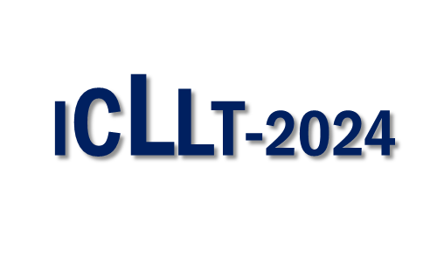

4th International Conference on
Light and Light-Based Technologies

May 16-18, 2024
Gazi University Photonics Application and Research Center
Gazi University Photonics Department, Faculty of Applied Science

Name Surname
Title
Institution /Company
Address:
E-mail
Phone
Participation type | Listener | Speaker | Poster

Please send your Registration Form to icllt@gazi.edu.tr by e-mail.

