Başlık (Calibri,14 punto)

**Adı Soyadı (Calibri, Bold, 11 punto)**

*Üniversite, Fakülte, Bölüm, Şehir, Posta Kodu (Calibri, Italic,11 punto)*

**Özet.** (Calibri, 10 punto) The presentation text starts here and continues. It is the random form of the text. Random text is the text, random text is the continuation. It is the random form of the text. Random text is the text, random text is the continuation. It is the random form of the text. Random text is the text, random text is the continuation. . Random text is the text, random text is the continuation. It is the random form of the text. Random text is the text, random text is the continuation.

**Anahtar Kelimeler:** (Calibri, 10 punto, en fazla 5 adet)

Kısa giriş ve metotlar (Calibri, 11 punto). It is the random form of the text. Random text is the text, random text is the continuation. It is the random form of the text. Random text is the text, random text is the continuation (Fig. 1). It is the random form of the text. Random text is the text, random text is the continuation. . Random text is the text, random text is the continuation. It is the random form of the text. Random text is the text, random text is the continuation [1].

**Tablo 1.** *Tablo başlığı (Calibri, Italic,10 punto)*

|  |  |  |
| --- | --- | --- |
| Random | text | Random text |
| continue | Random text | Random text |
| Text | Random text | continue |
|  |  |  |
| Text | Random text | continue |

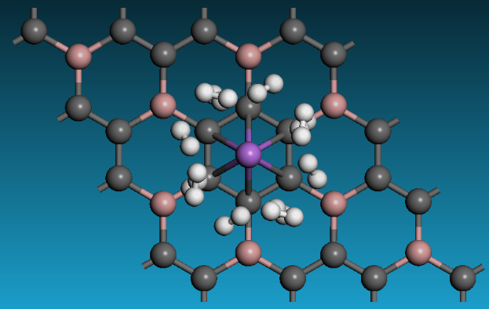

**Şekil 1**. *Şekil başlığı (Calibri, Italic,10 punto)*

Kısaca sonuçlar. It is the random form of the text. Random text is the text, random text is the continuation. It is the random form of the text. Random text is the text, random text is the continuation (Table 1). It is the random form of the text. Random text is the text, random text is the continuation. . Random text is the text, random text is the continuation. It is the random form of the text. Total abstract should be maximum one page [2].

**Kaynaklar** (Calibri,10 punto)

1. M. Parstky, A. Basr, F. Benetti, M. Trapso, G. Norosk, “Nonlinear nonrelative example journal and shifts”, Journal of Tranps Triology 393, 1033–1042 (2009).
2. A. Diroya, L. Vacsari, A. Bekas, G. Norask, "Infracold Mitroscopy: a sided-screening platform for searching upon infection", AKS Kriyoal Kemiscience, 2(3), 160–174 (2011).