Mechanical Tests Laboratory
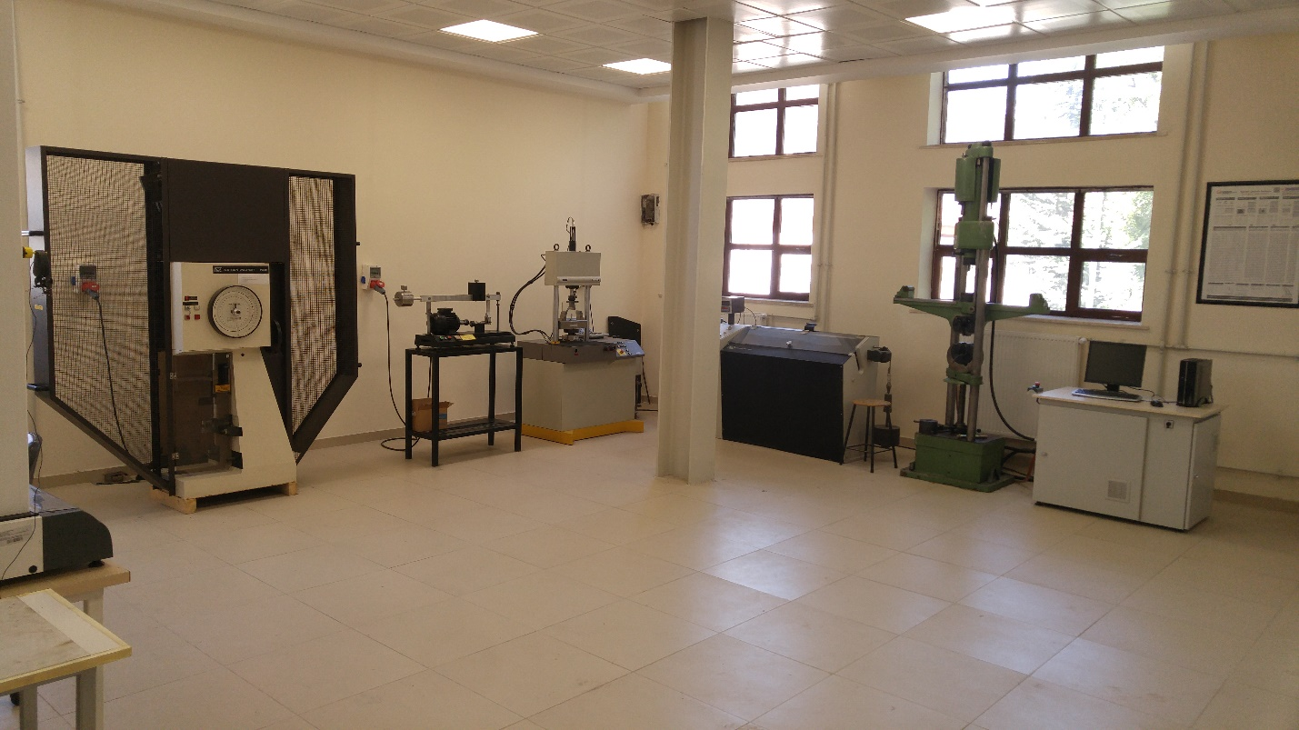
- Vickers Hardness Tester (Avery)
- Tensile – Compression - Bending Test Device (MFL 200 kN)
- Izod Impact Testing Device (Avery)
- Brinell Hardness Tester (Avery)
- Rockwell (A, B, C) Hardness Tester (Page Wilson)
- Rotating Bending Test Device
- Charpy Impact Testing Device (Instron – Wolpert PW 30 ( 150 J))
- Creep Testing Machine (MTS)
- Torsion Testing Machine (Instron - Wolpert)
- Universal Tensile – Compression - Bending Test Device (Instron 8503 (20kN))
- Universal Tensile – Compression - Bending Test Device (Instron 8503 (500kN))
- Vickers, Rockwell, Brinell Hardness Tester (Instron – Wolpert Dia-testor7551)
- Portable Hardness Tester (Instron – Wolpert (Hv 1kg))
- Mechanical Alloying Mill (Szegvari Type)

Metallography Laboratory

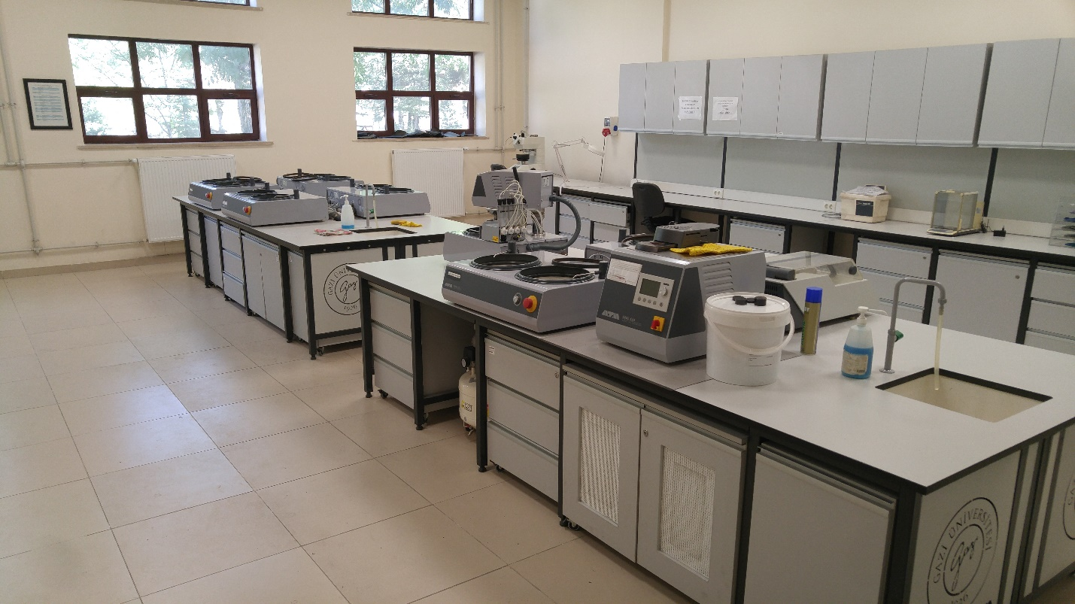
- Automatic Polishing Device (Metkon Gripo 300-1V)
- Automatic Fluid Dispenser (Metkon Dispomat)
- Polishing Device (Struers Metapolan)
- Vibratory Polisher (Metapolan)
- Double Wheel Grinding and Polishing Machine (Metasinex)
- Ultrasonic Cleaning Device (Struers Metason-60)
- Abrasive Cutting Device (Metkon Servocut)
- Hot Mounting Device (Metkon DigiPress)
- Hot Mounting Device (Struers Press to Press)
- Specimen Dryer (Sinbo)
- Specimen Storage Cabinet
- Consumables Storage Cabinet

Optical Microscopy Laboratory

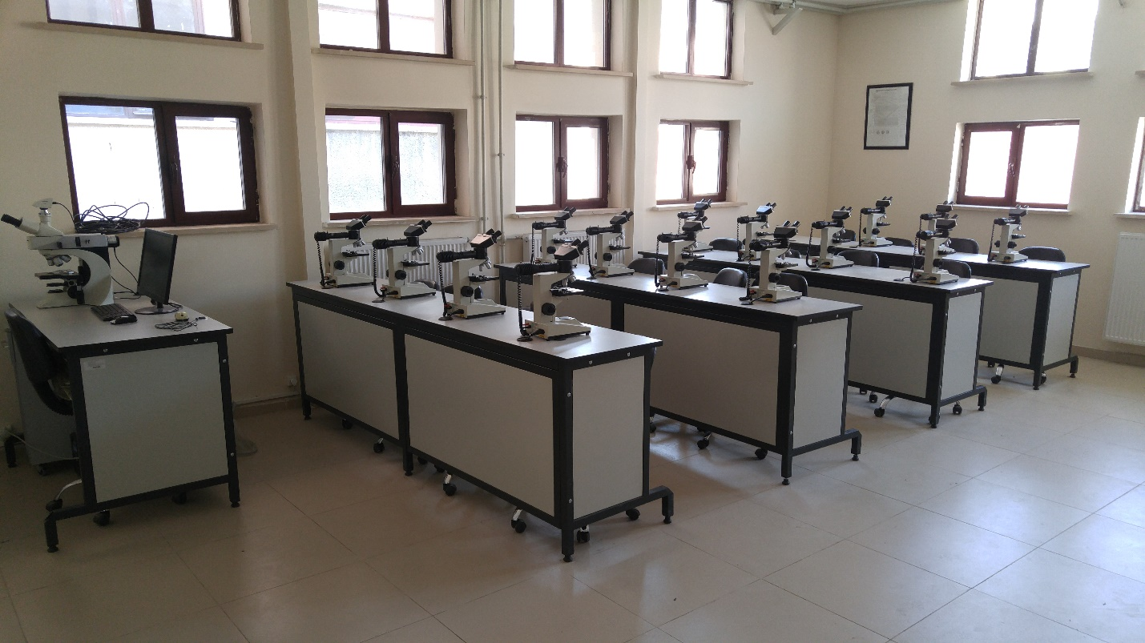
- Optical Microscope (Prior x50-x1000) – 15 pcs.
- Optical Microscope (Olympus x50-x1000) – 4. pcs.
- Inverted Microscope (Olympus x50-x1000)
- Optical Microscope Prior (x50-x1000, integrated with Panasonic digital camera)
- Optical Microscope Leica DM4000M (x25-x1000, integrated with Leica DFC320 digital camera)

Heat Treatment Laboratory
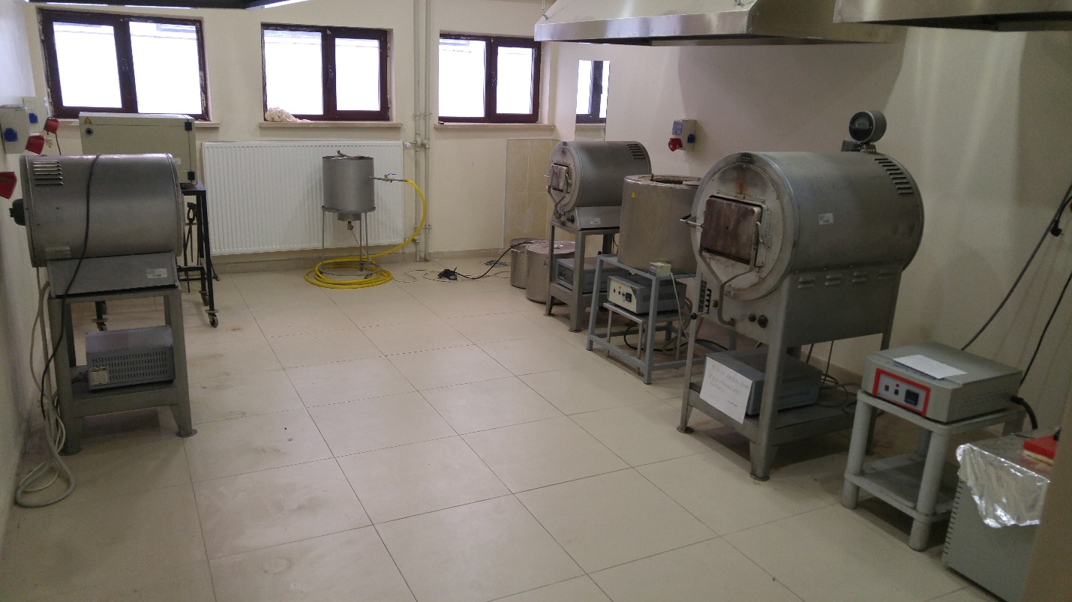
- Muffle Furnace (max. 1150 C, Hereaus)
- Vertical Tube Furnace (max. 1400 C, SFL SC 1206)
- Horizontal Tube Furnace (max 1400 C, SFL SC 1206)
- Box-type Heat Treatment Furnace (max. 1400C, SFL MFC 1197)
- Time-Temperature Datalogger (ABB Instrument)
- Digital Temperature Gauge – 3 pcs.
- Oil Bath (max. 500C, Alser Protherm)
- Salt Bath (max. 500C, Alser Protherm)

Scanning Electron Microscope (SEM) Laboratory

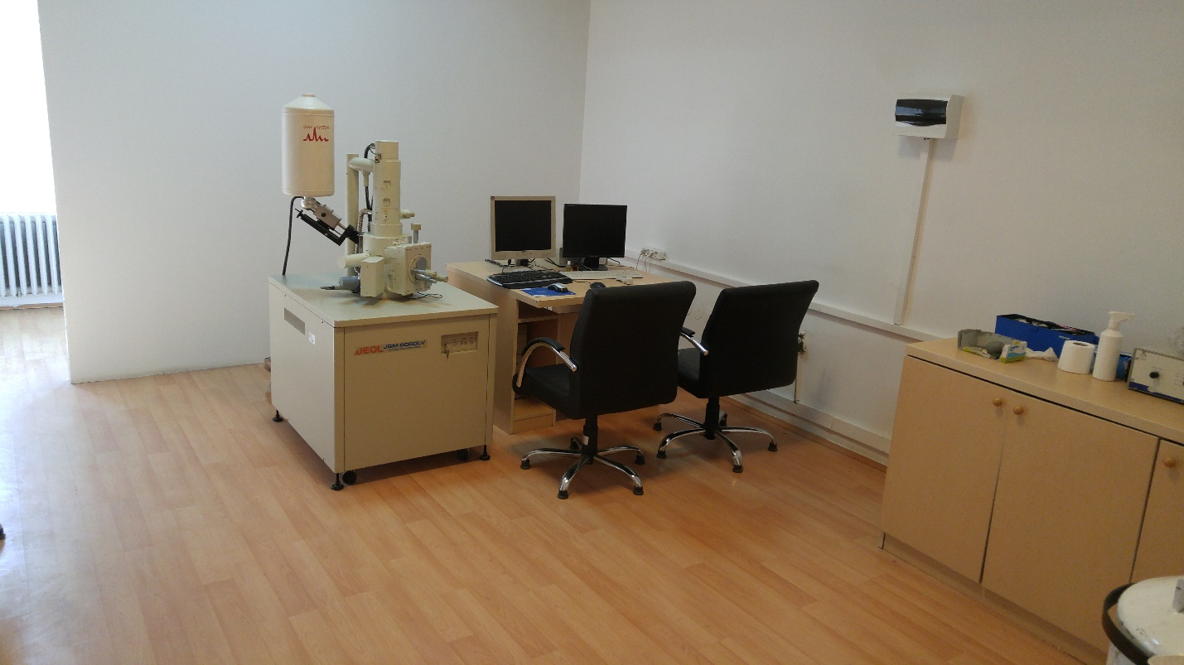
- Scanning Electron Microscope (JEOL JSM 6060 LV)
- EDS-Energy Dispersive X-Ray Spectrometer (IXRF Instruments)
- Specimen gold coating unit.
- Specimen carbon coating unit.

3D Modeling Laboratory – Optical Emission Spectrometry

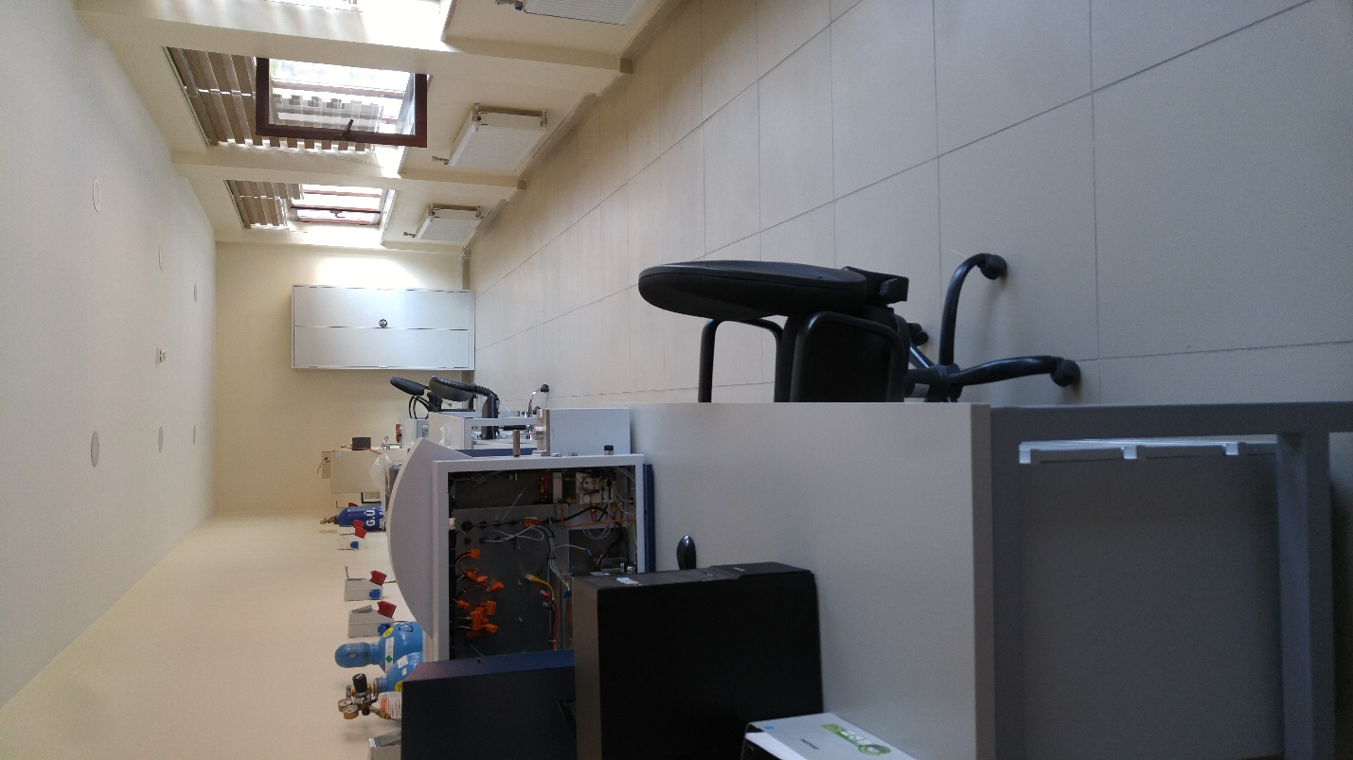
- Spectral analyzer (Bruker)
- 3D Printer (Makerbot)
- Elemental Analysis Device (Leco)

Welding Workshop

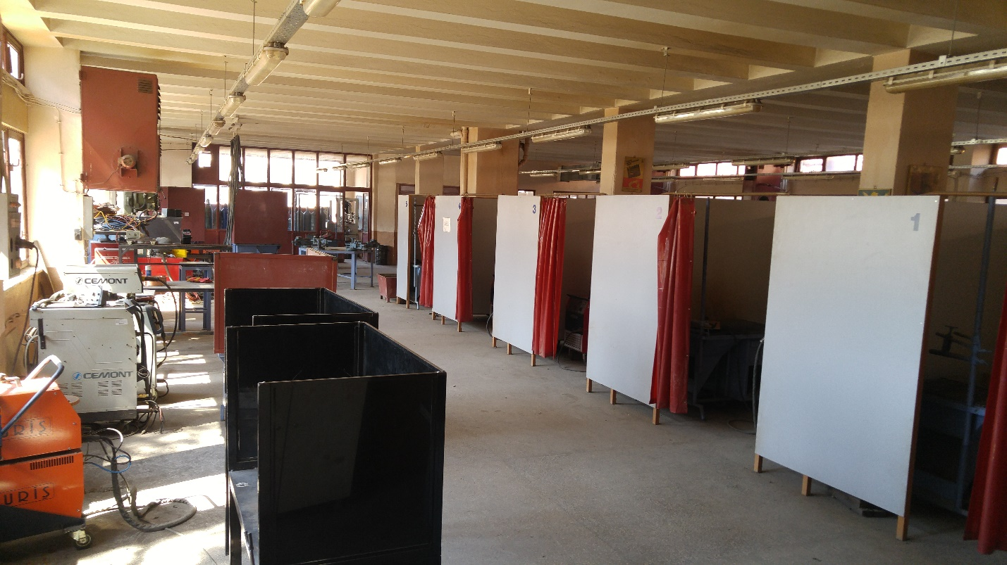
- Guillotine Shears
- Press Brake
- Spot Welding Machine
- Pillar Drill
- Jig Saw
- Punch Press
- Combined Shears
- Gas Metal Arc Welding Machine – 6 pcs.
- Electric Arc Welding Machine – 4 pcs.
- Grinding Machine – 2 pcs.

Basic Metal Processing Workshop

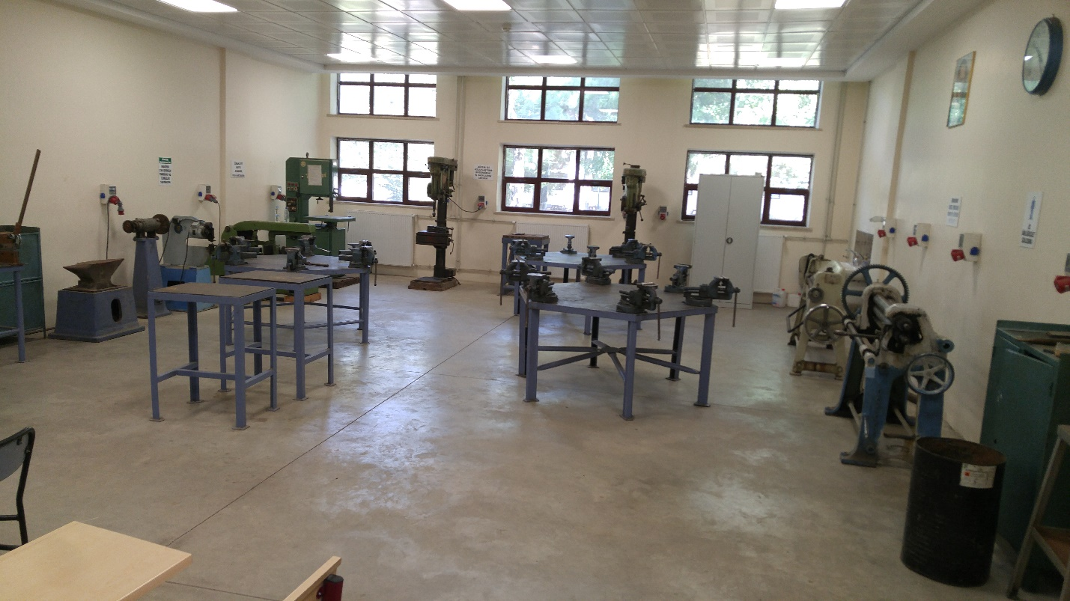
- Bench Drill
- Jig Saw
- Hydraulic Saw
- Bandsaw
- Pillar Drill – 2pcs.
- Metal Clamping Machine with Arm
- Plate Bending Machine

Powder Metallurgy Laboratory

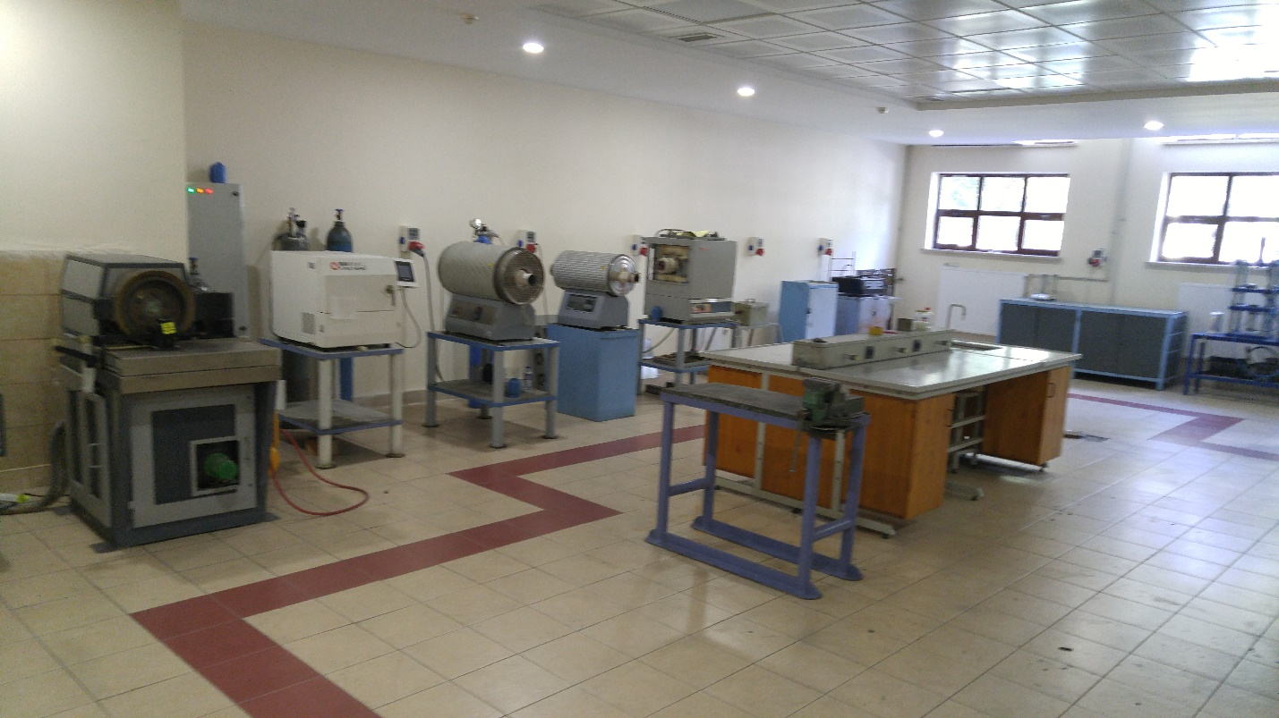
- Hydraulic Press
- Turbula Powder Mixer – 2 pcs.
- Microwave Oven
- Abrasive Analysis Device
- Horizontal Tube Furnace – 3 pcs.

Metal Casting Laboratory

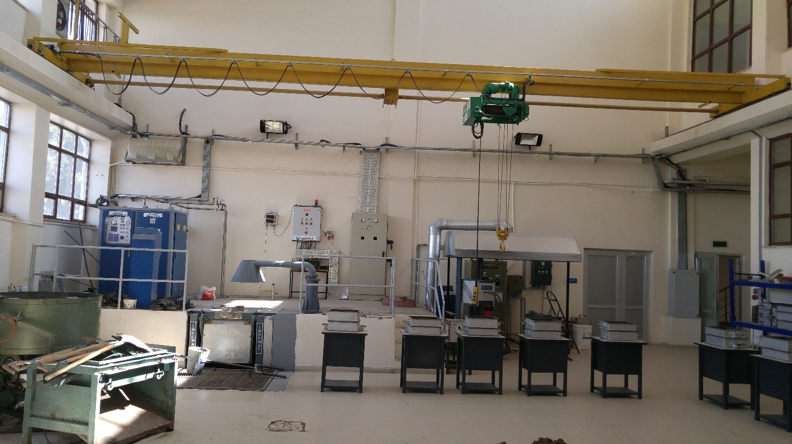
- Sand mixing device – 2 pcs.
- Electrical Metal Melting Furnace – 2 pcs.
- Injection Moulding Furnace – 2 pcs.
- Portable Furnace
- Bandsaw
- Small Size Turning Lathe
- Bench Drill
- Pillar Drill
- Die Casting Machine
- Vacuum Density Tester

Metallurgy Laboratory

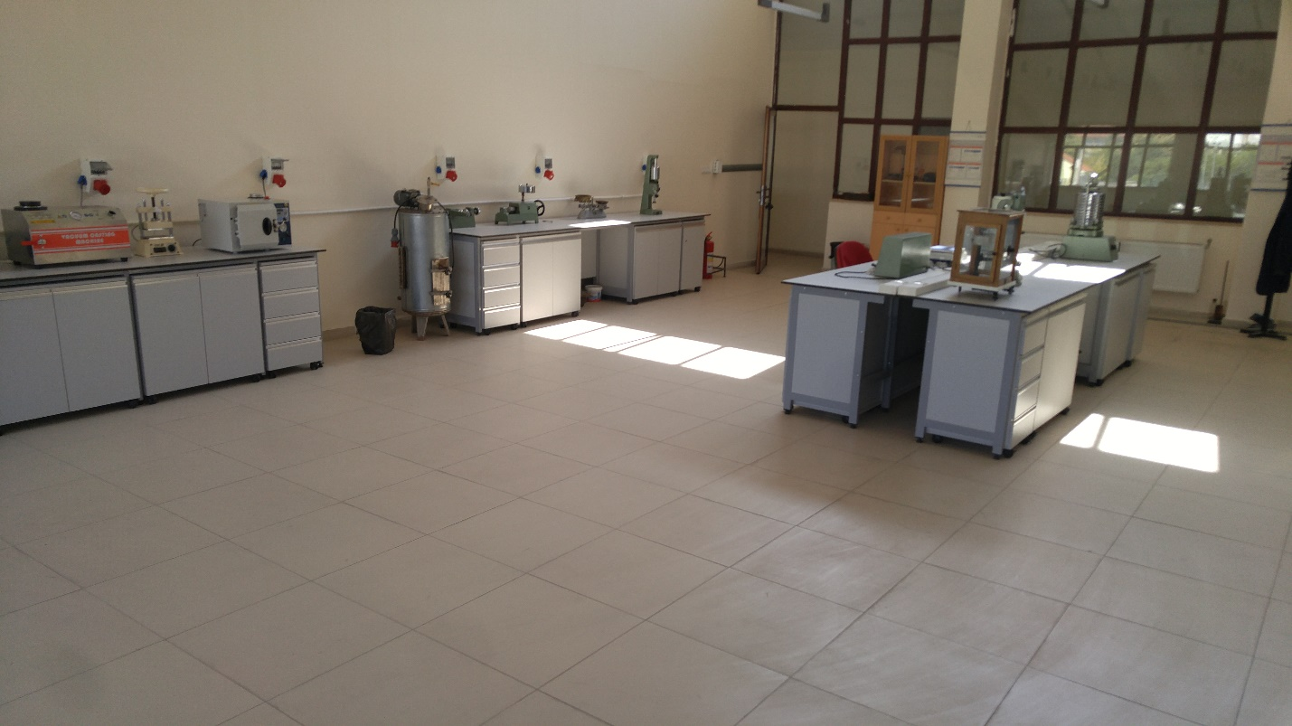
- Sand Grain Size Analyzer
- Wet-dry Strength Analyzer
- Vacuum Casting Machine
- Bench Top Sand Mixing Device
- Wax Injector
- Drying Oven – 2 pcs.
- Fume Hood
- Gas permeability Analyzer

X-Ray Diffraction Laboratory
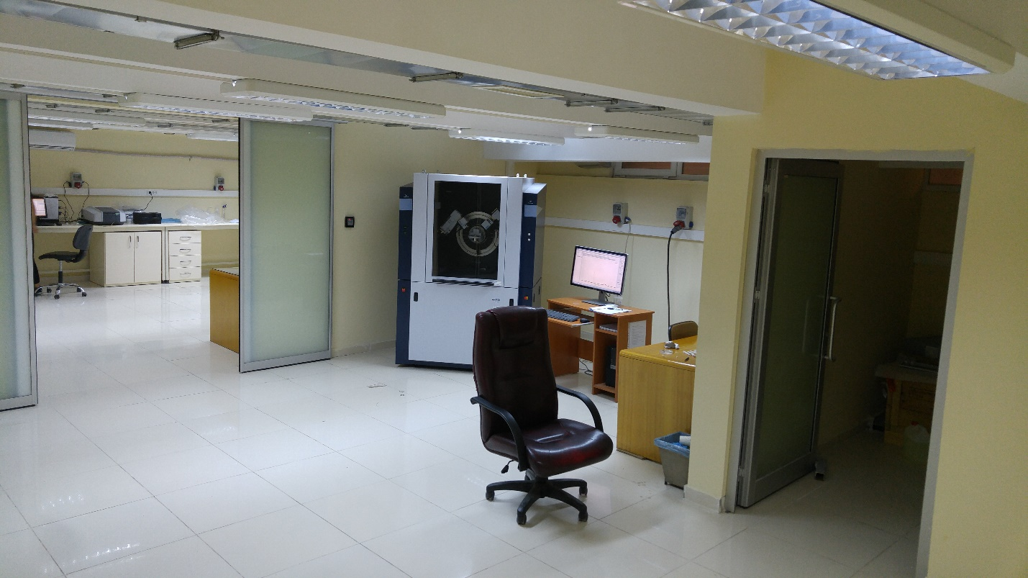
- X-Ray Diffraction Device (XRD)
- Thermogravimetric Analyzer (TGA)
- Differential Scanning Calorimeter (DTA)
- Ultraviolet-Visible Spectrophotometer (UV-VIS)

